Electricity Dataset Visualation

# Foley_2018.csv

Entire_Dataset_Plot.png

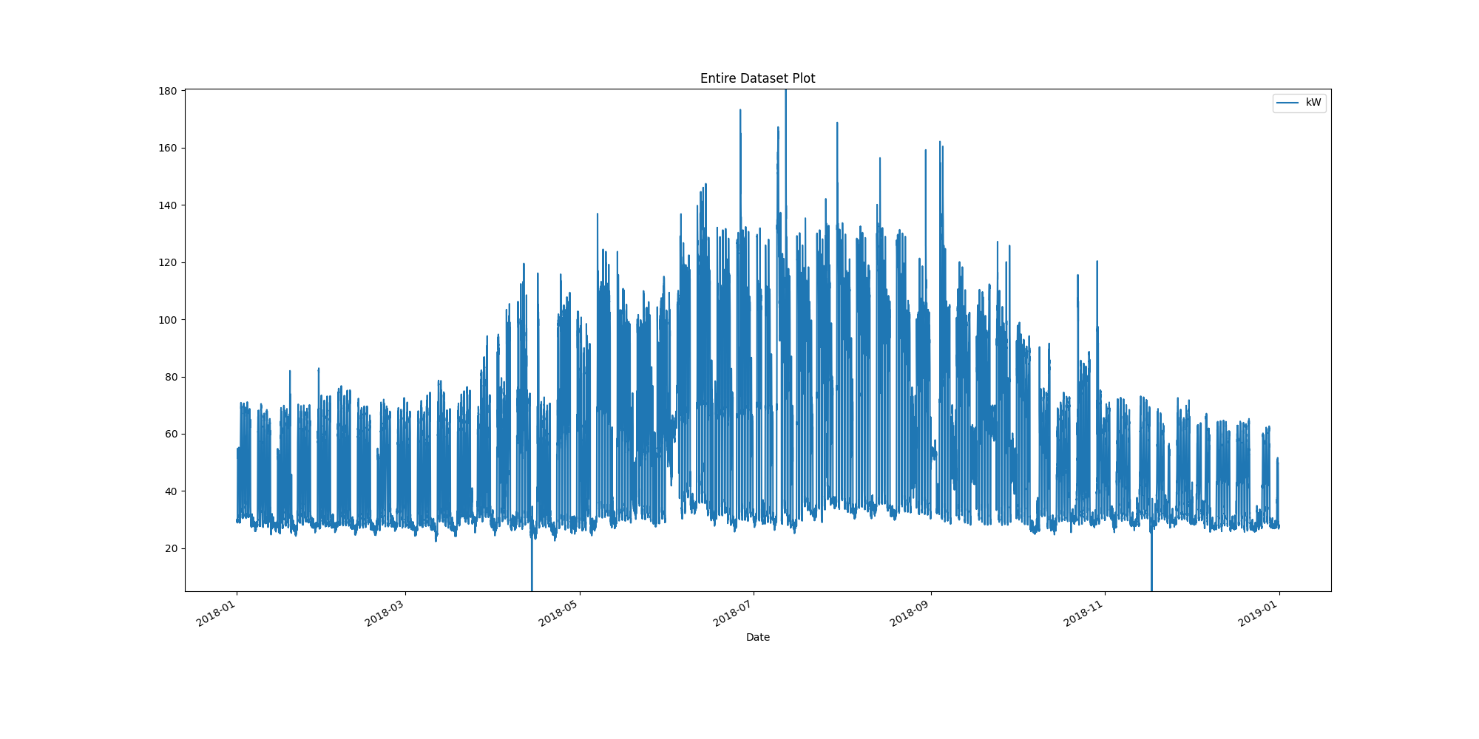

# Plot of month with max demand recorded

Month_maximum_recorded_demand.png

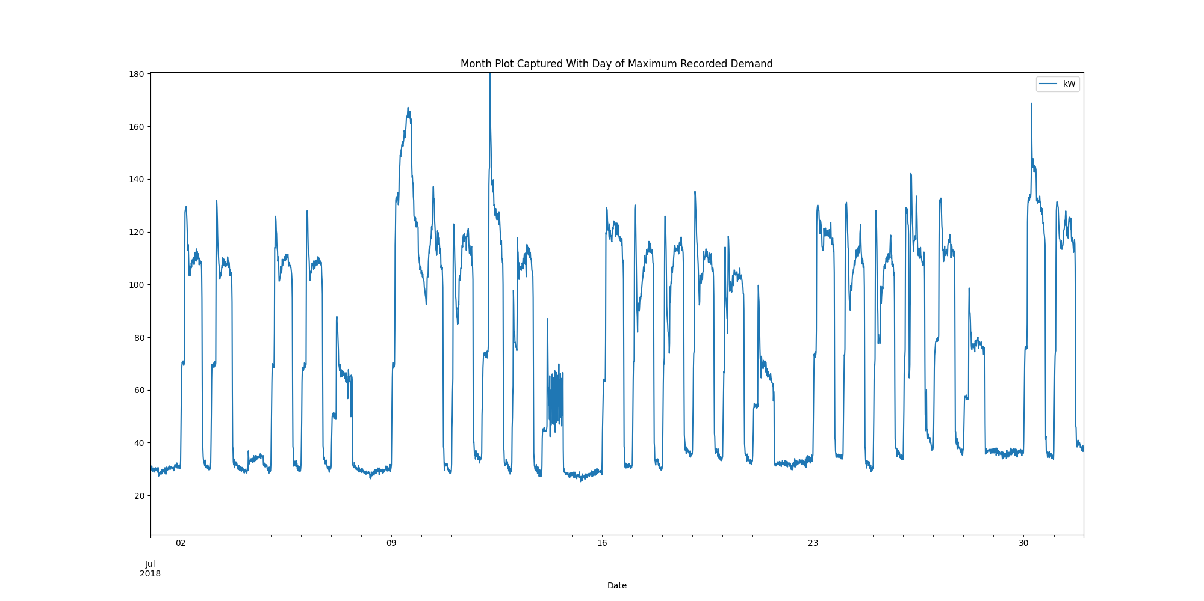

# Power box plots per month

AllDatakWboxPlots.png

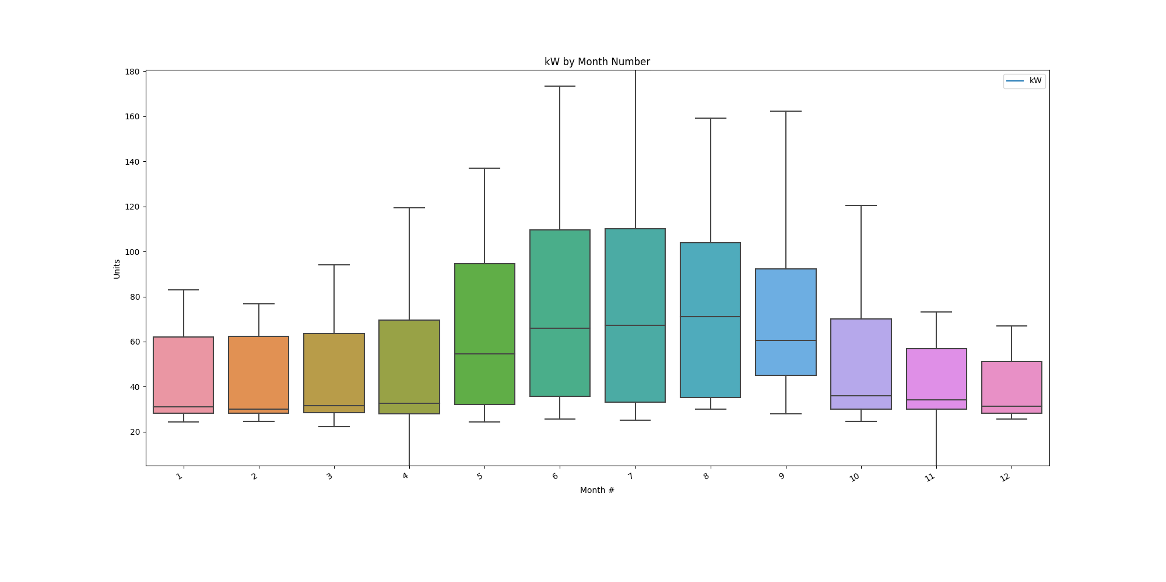

# Power consumption trends

kWtrendsPlot.png

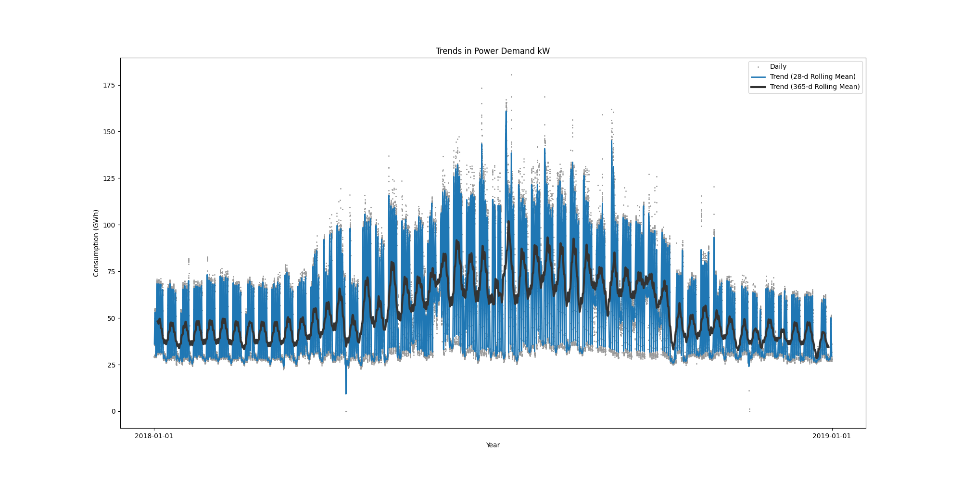

Data Analysis Report Winter

Winter Months Electrical Load Profiles

datasetPlot.png

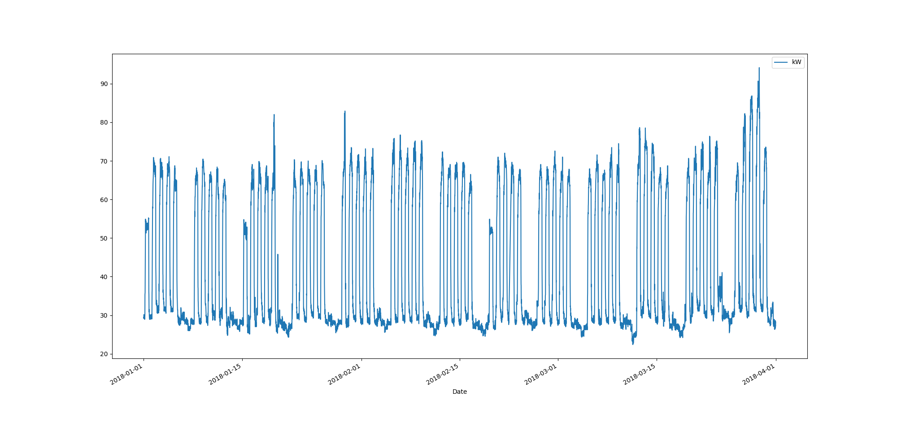

# Max Demand Found In Dataset

kW 94.162  
Name: 2018-03-29 15:30:00, dtype: float64

# Dataset Summary Statistics

kW  
count 8601.000000  
mean 42.192302  
std 17.591805  
min 22.388000  
25% 28.350000  
50% 31.050000  
75% 62.662000  
max 94.162000

# Highest Ranked Change Point Algorithm Detection

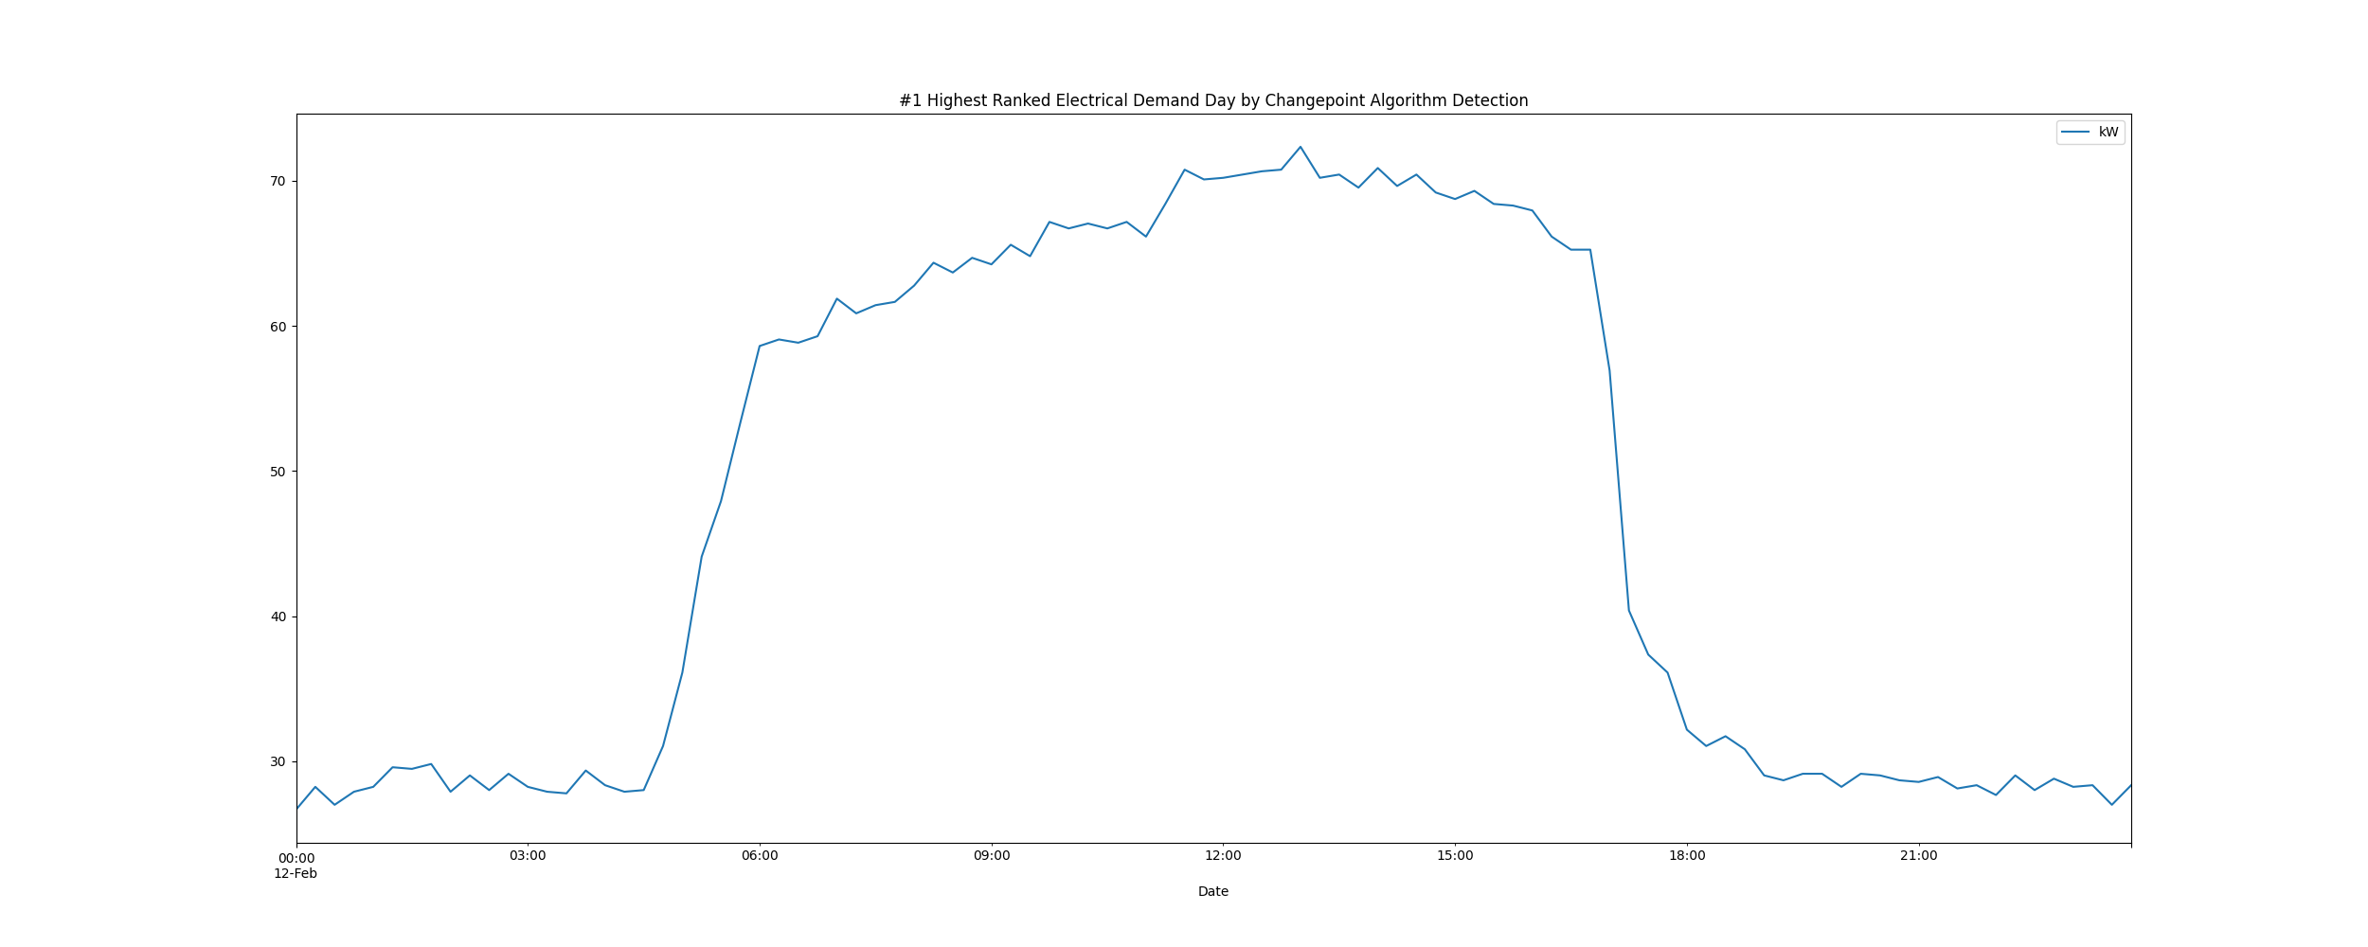

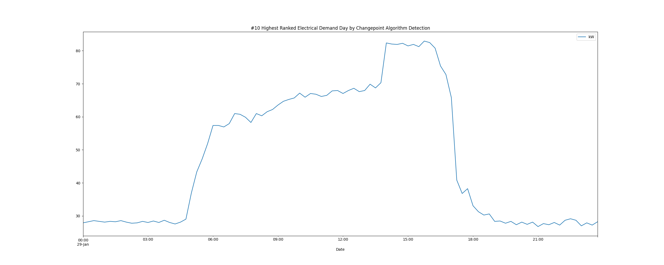

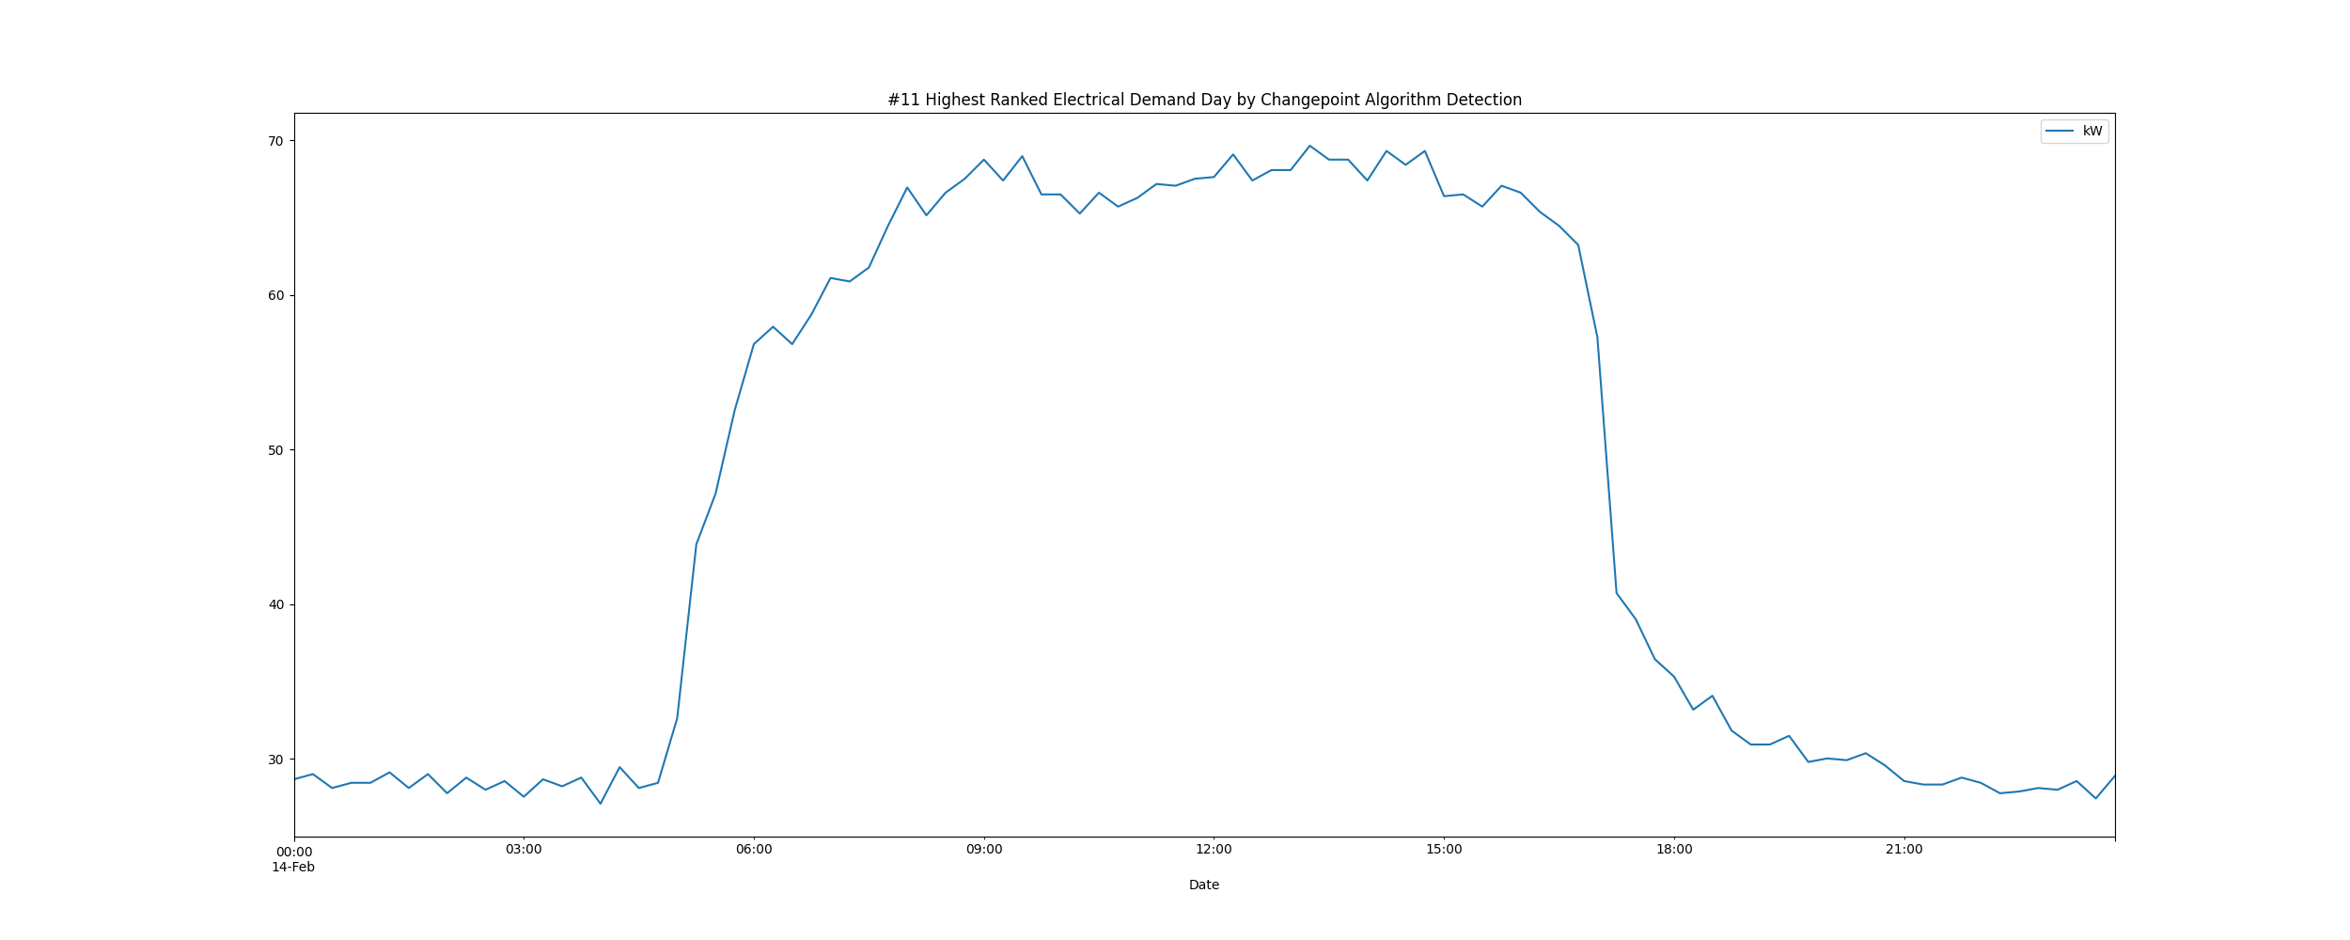

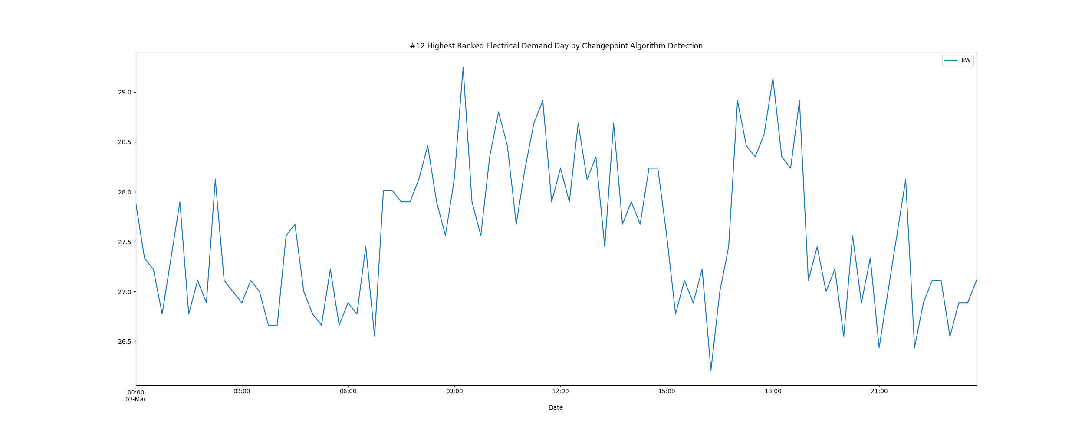

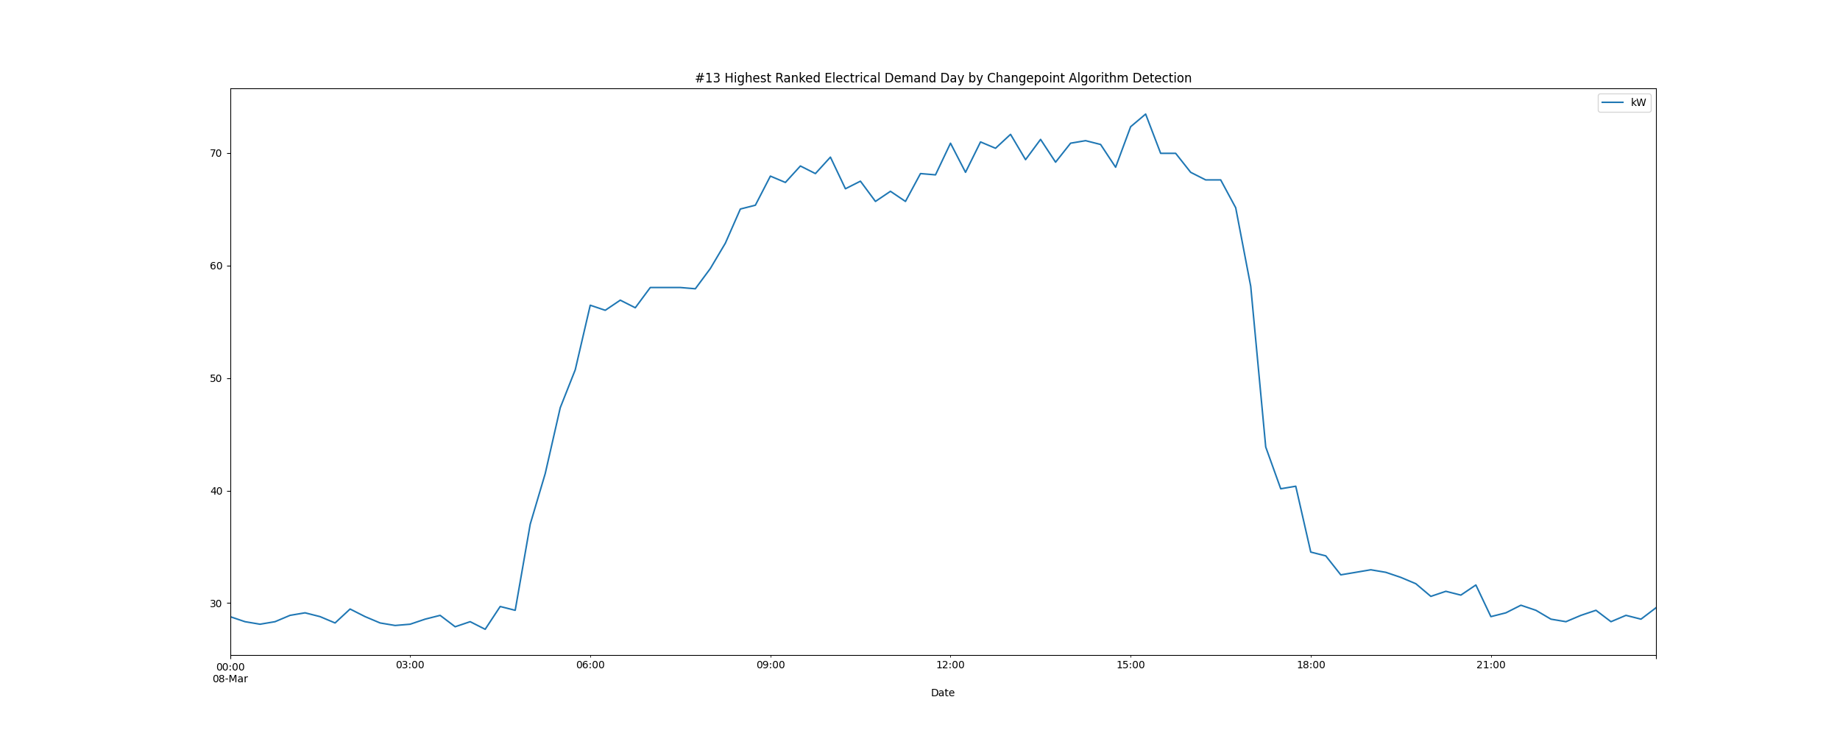

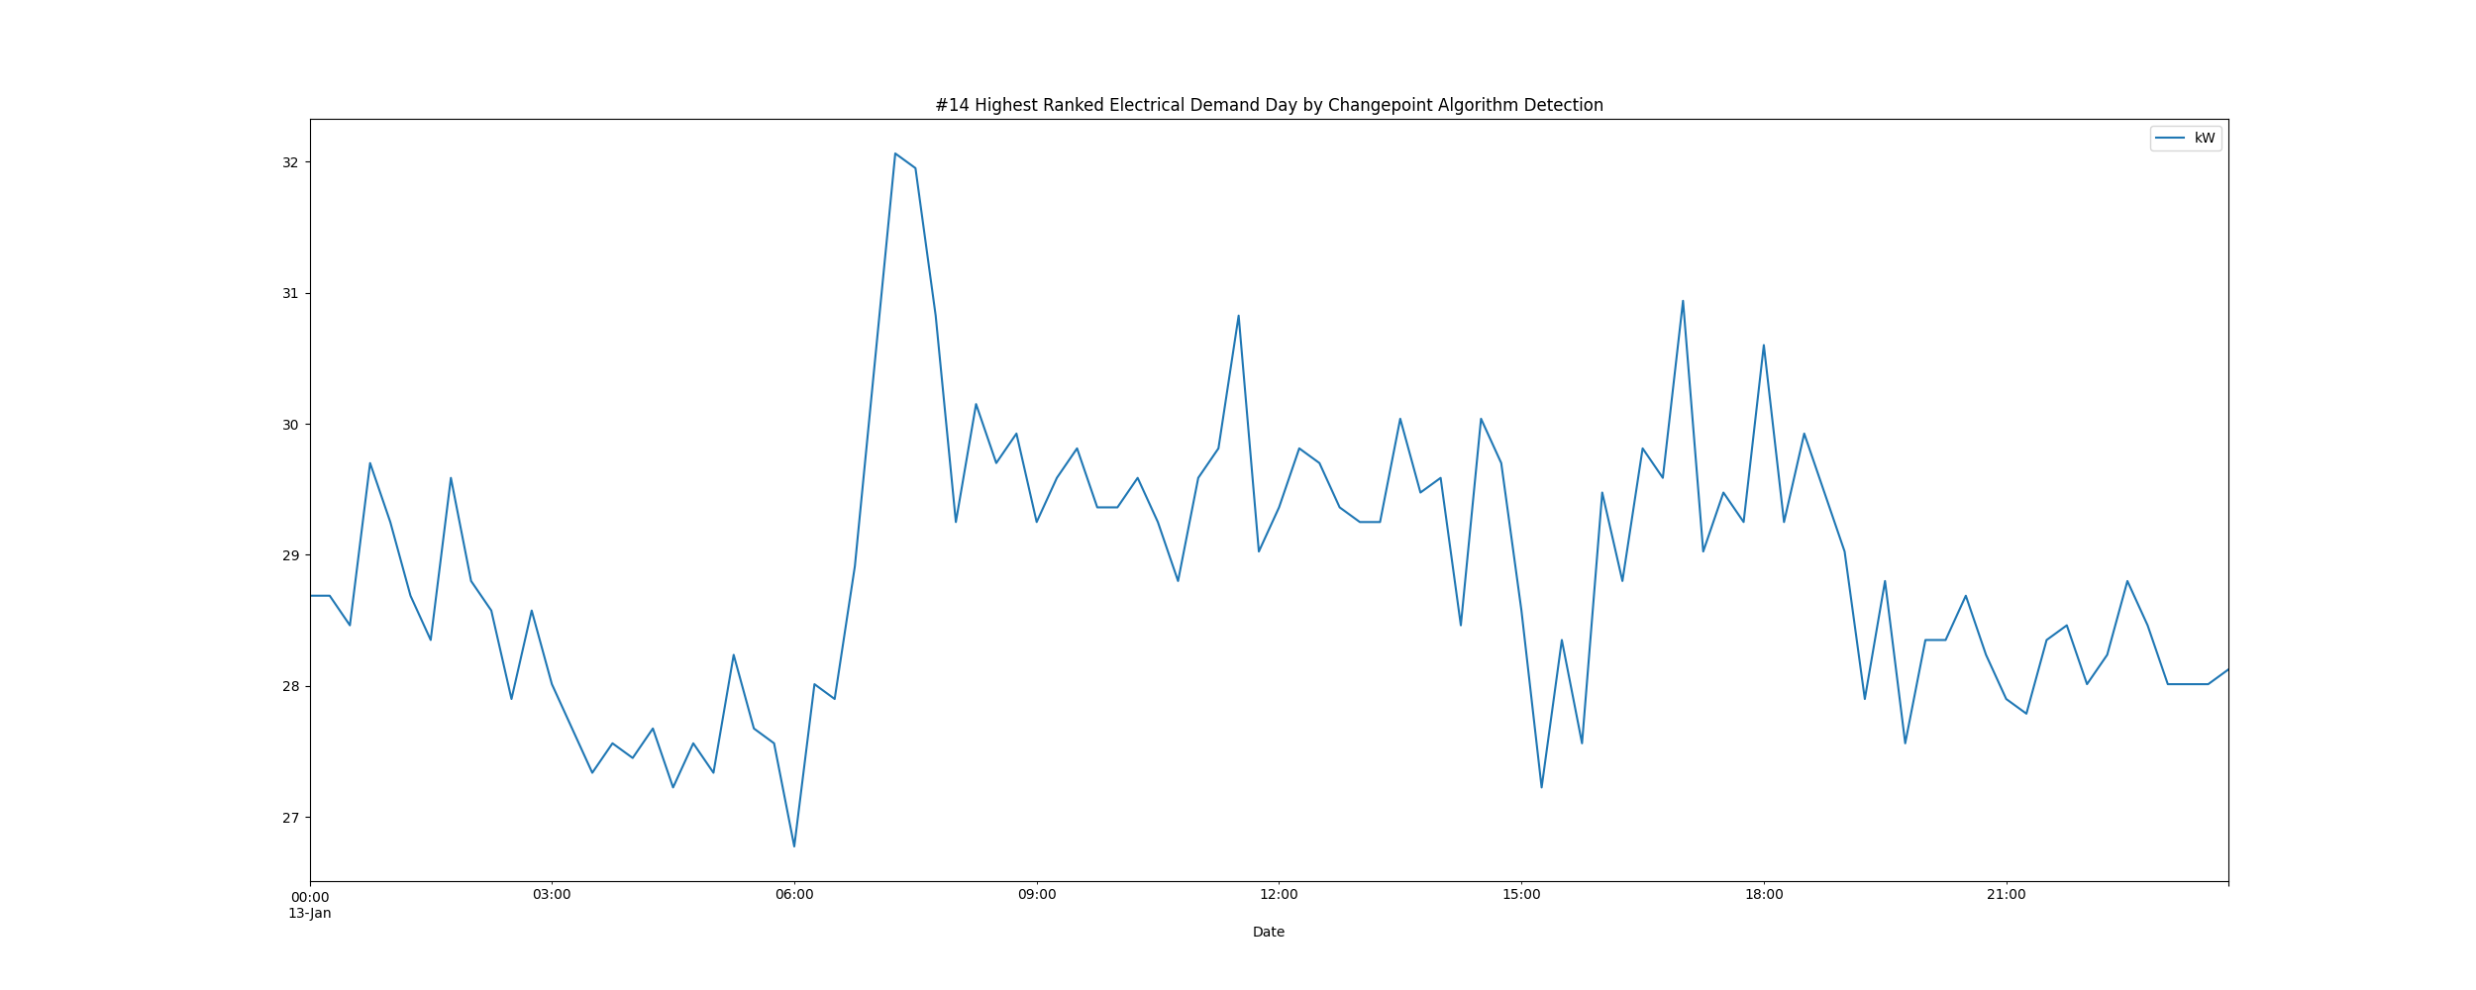

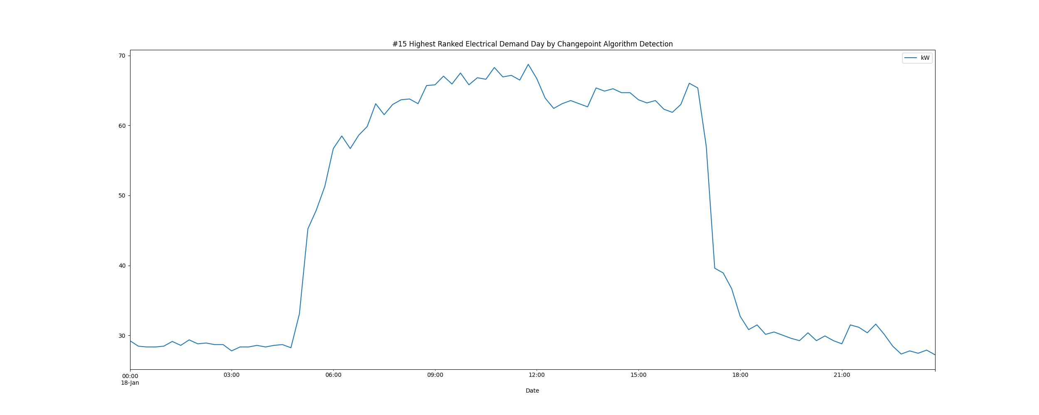

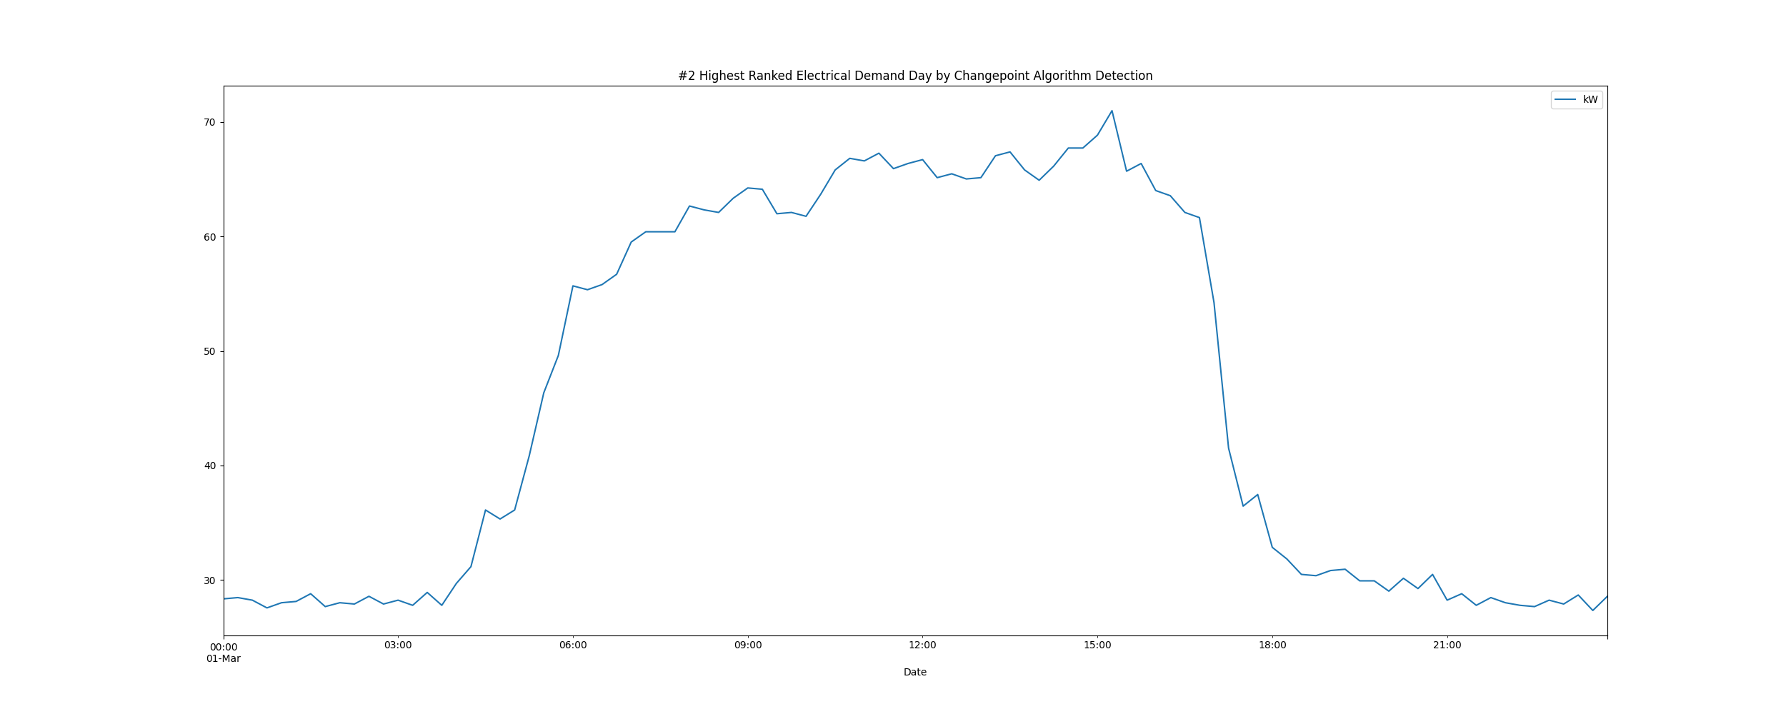

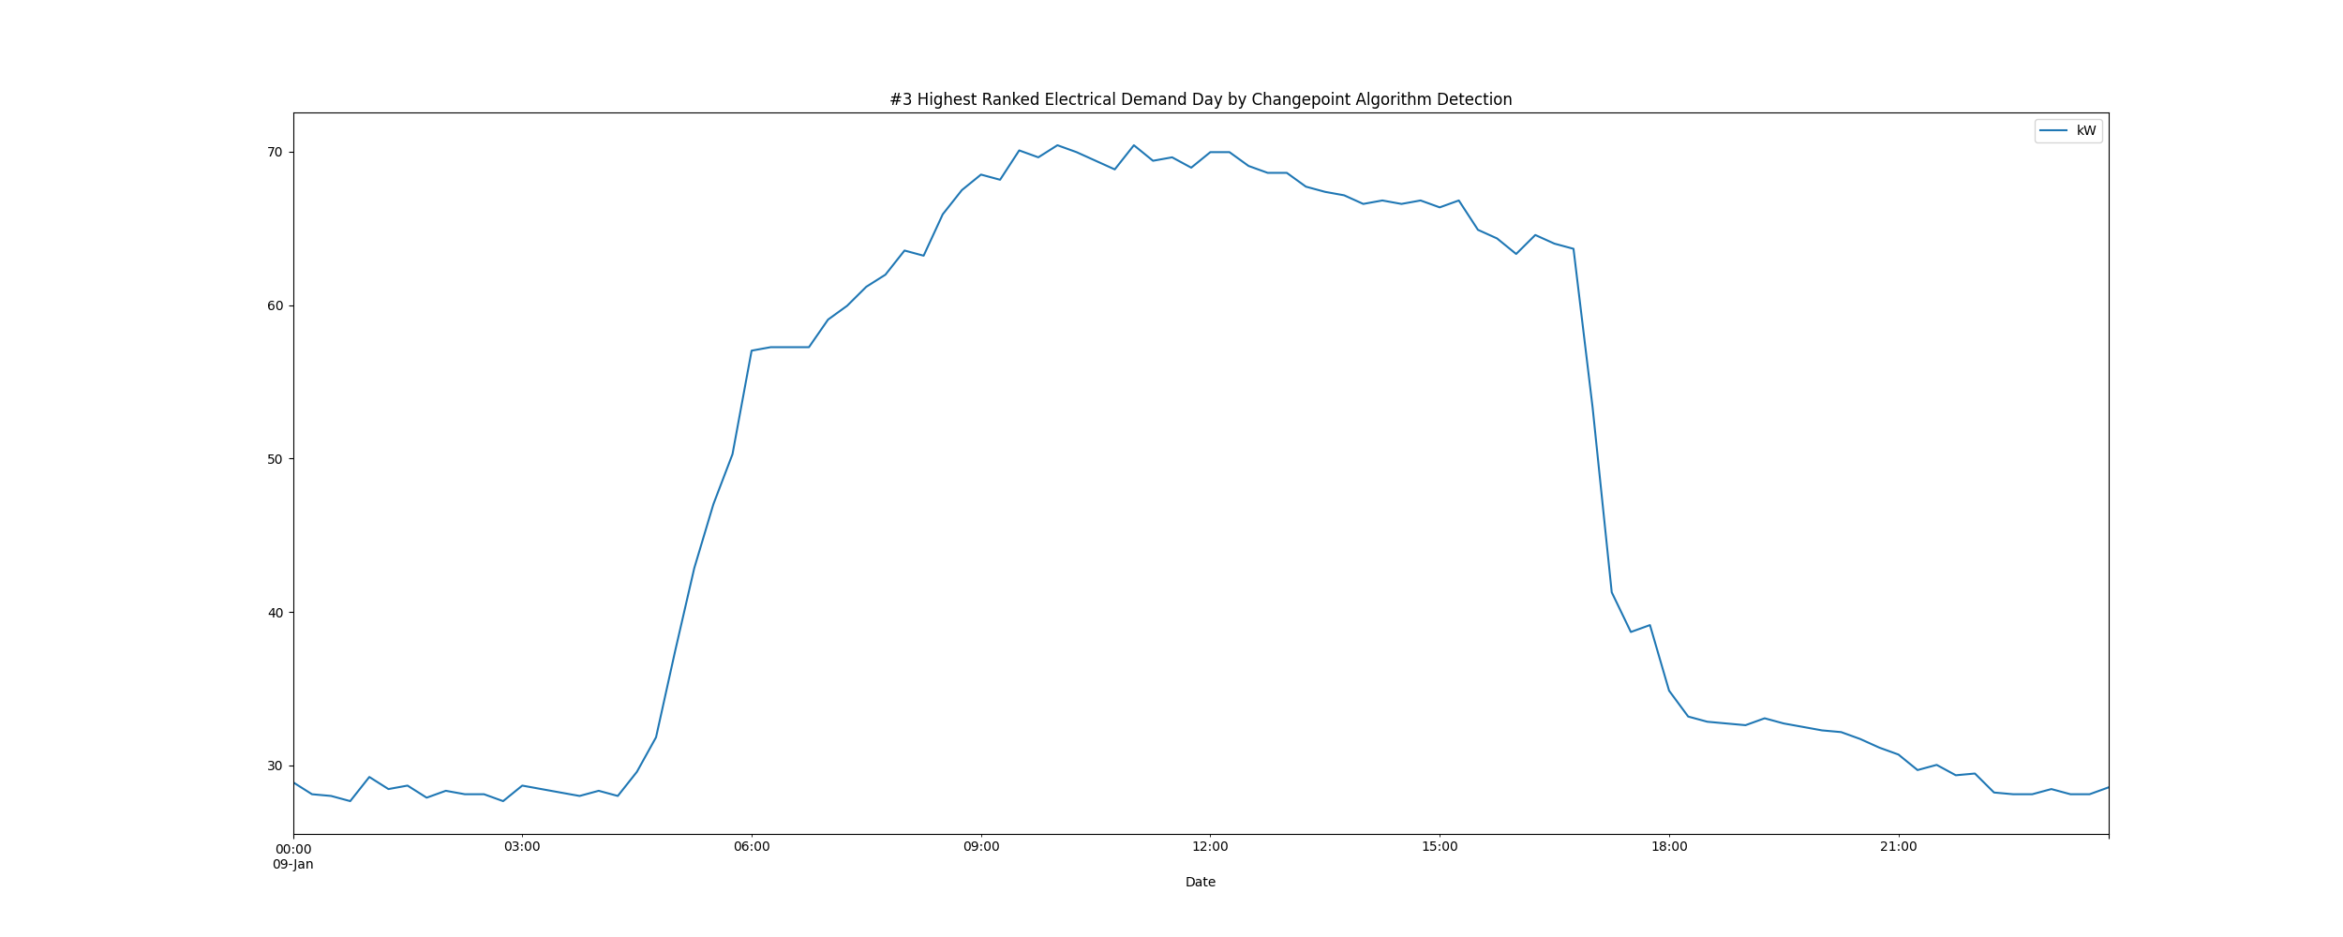

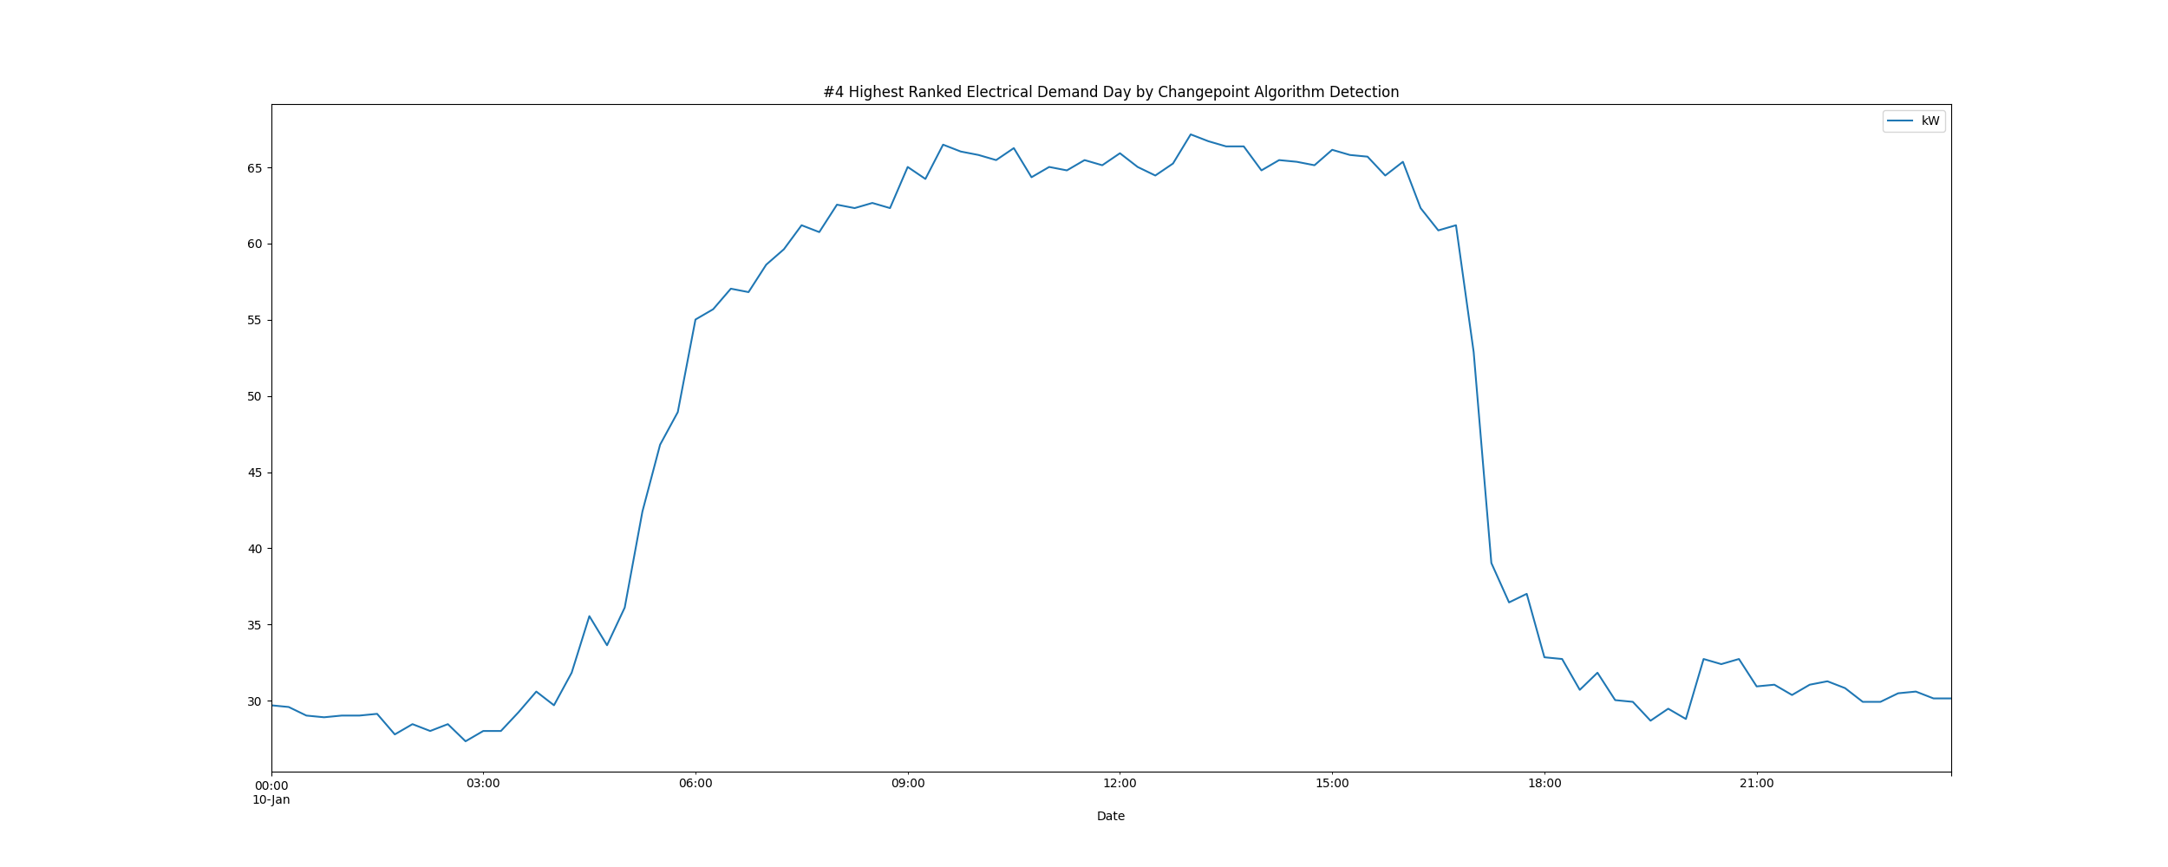

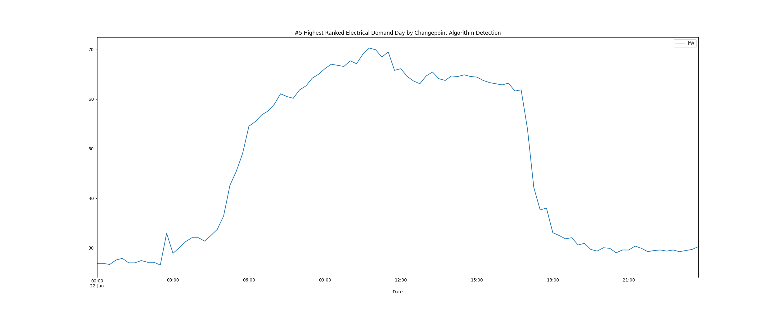

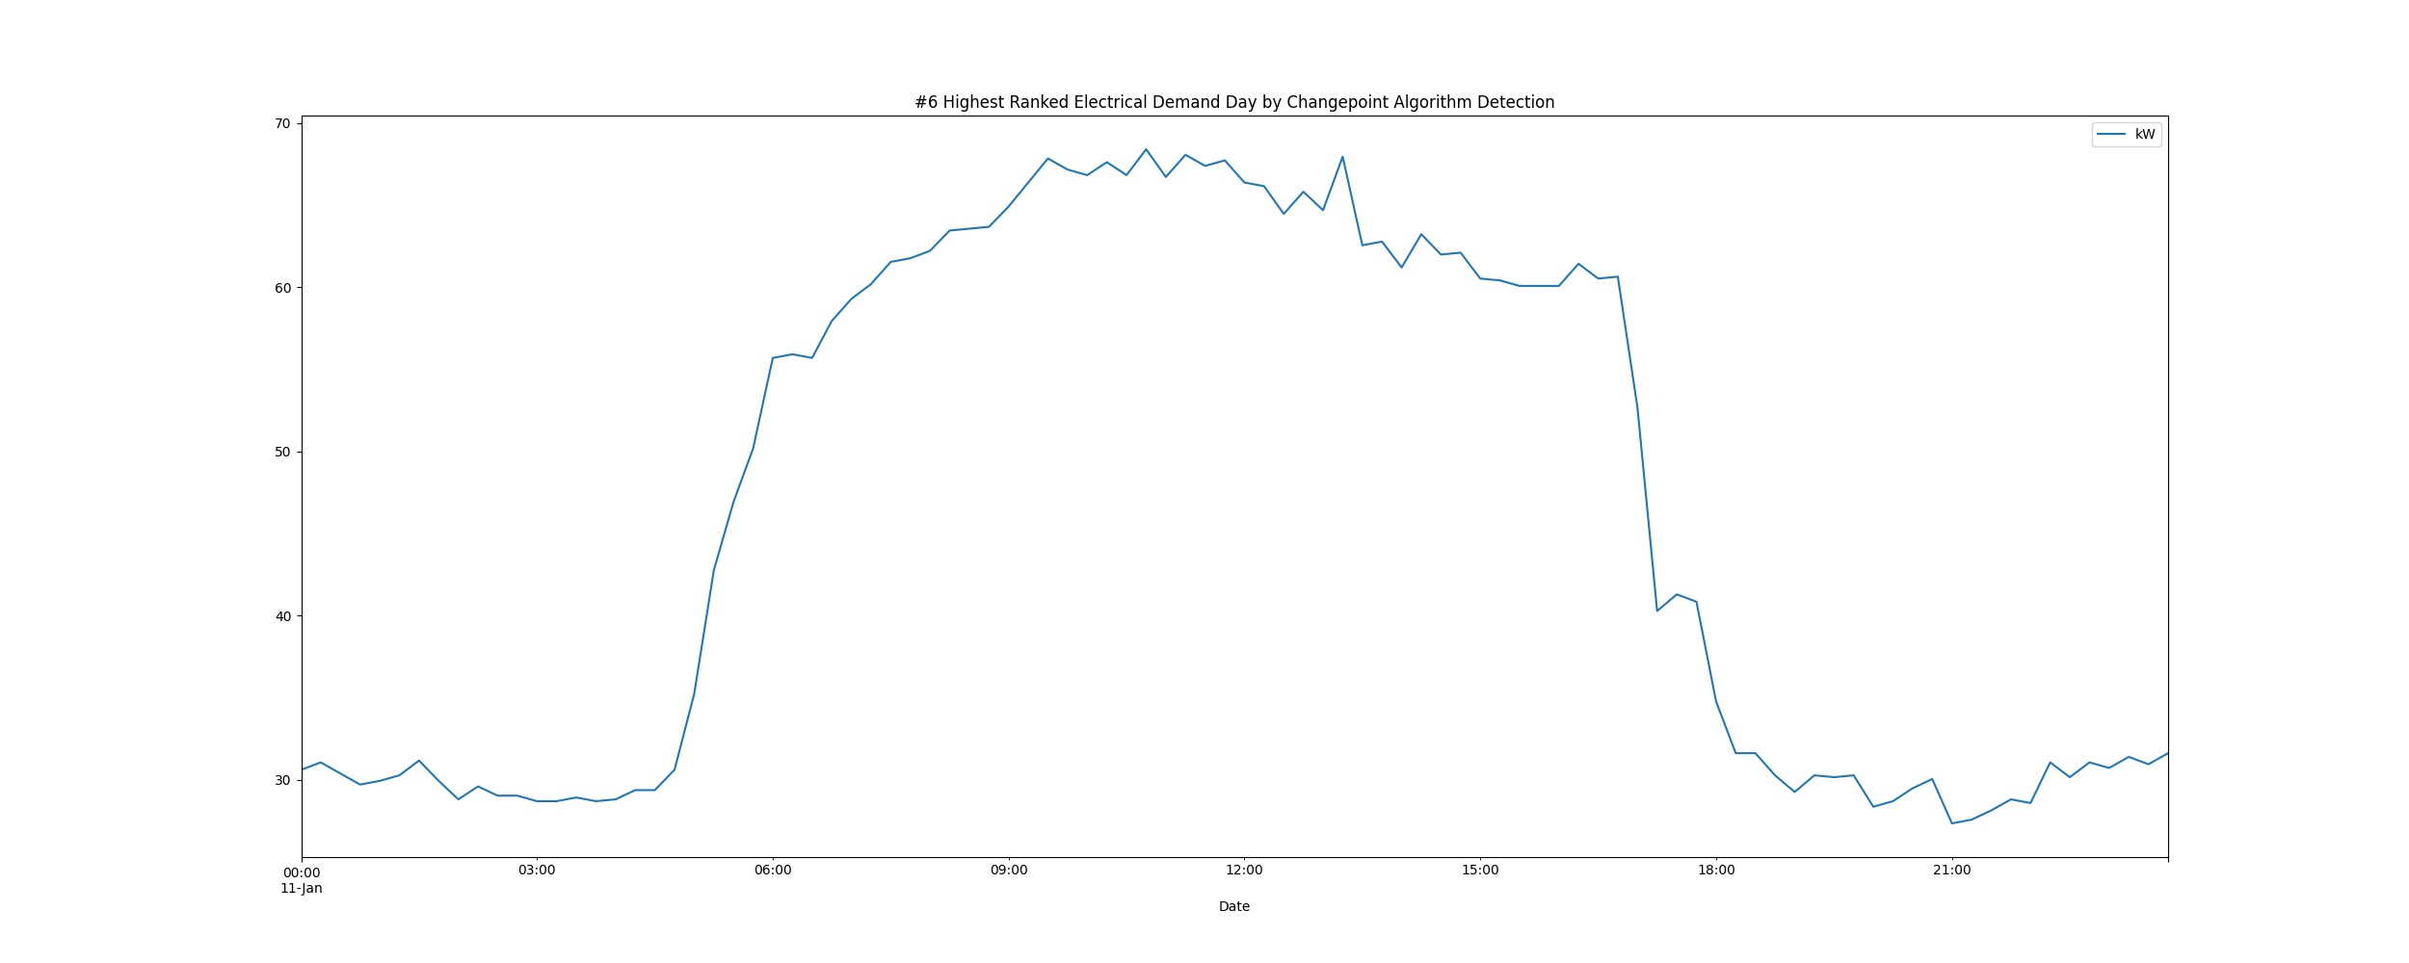

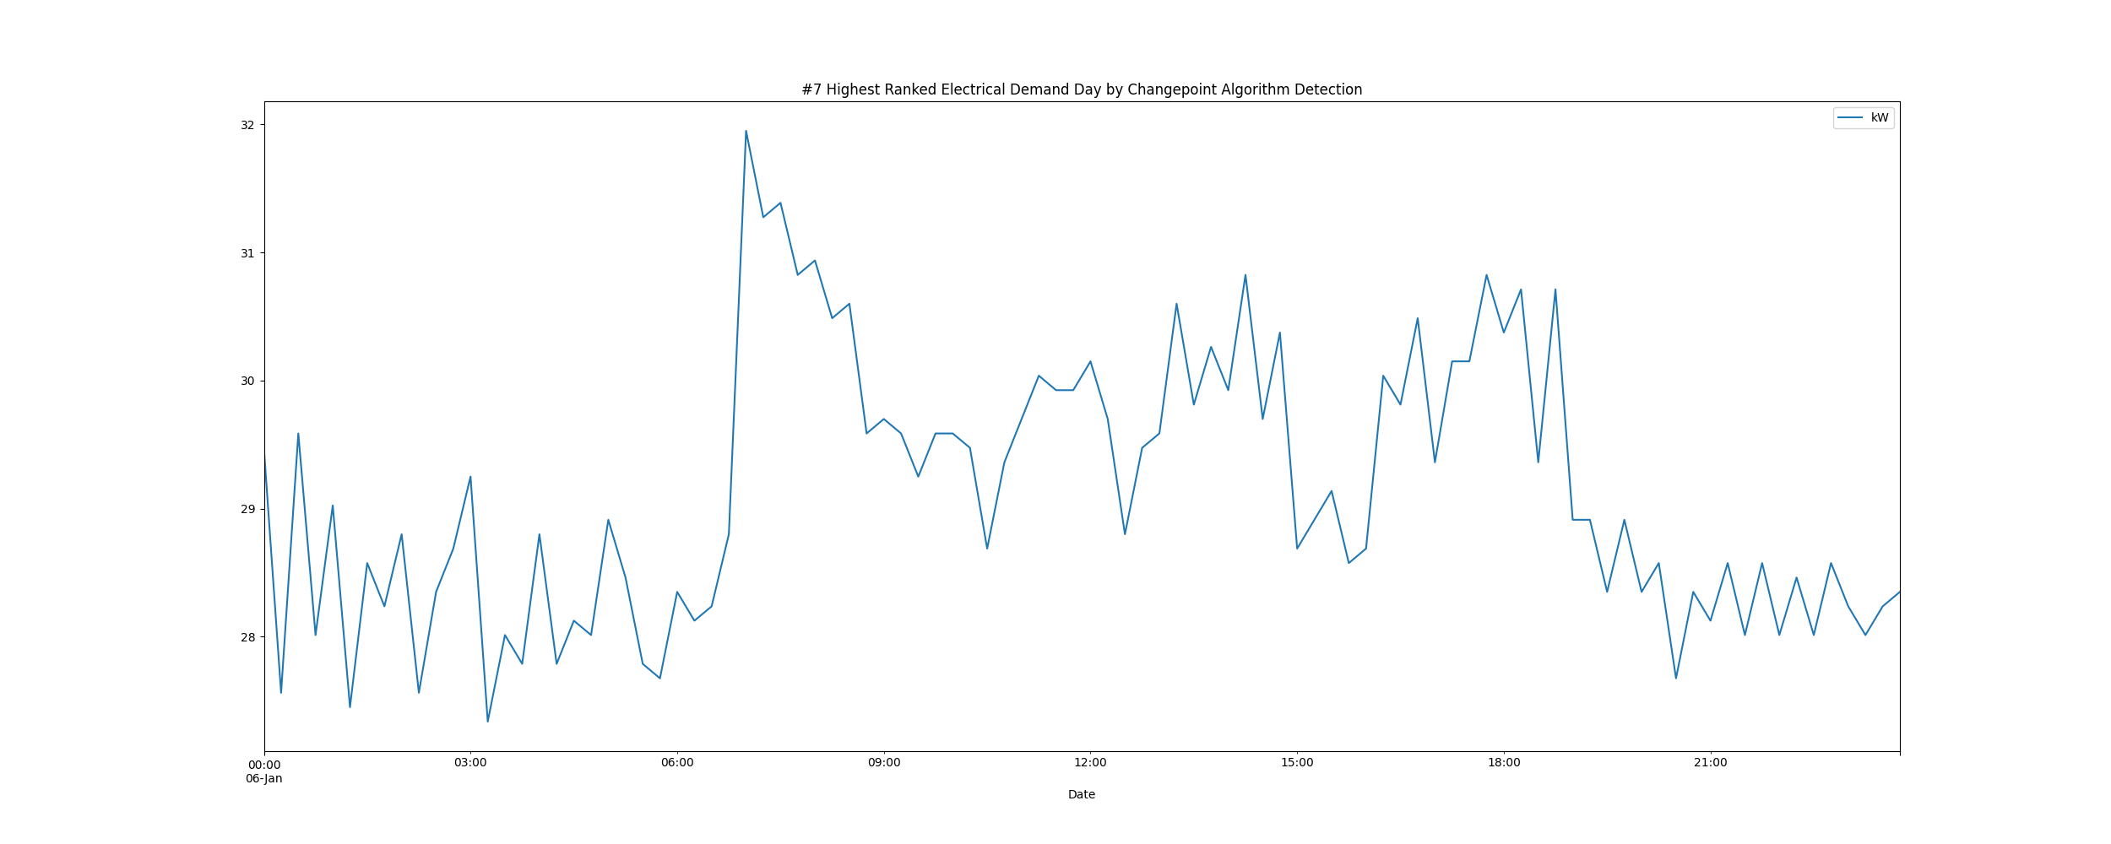

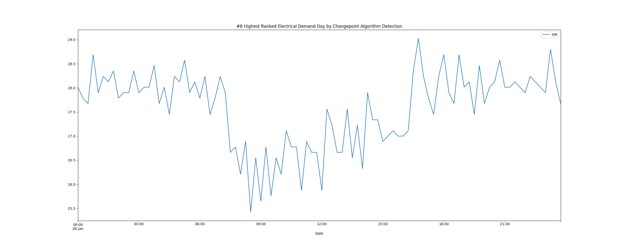

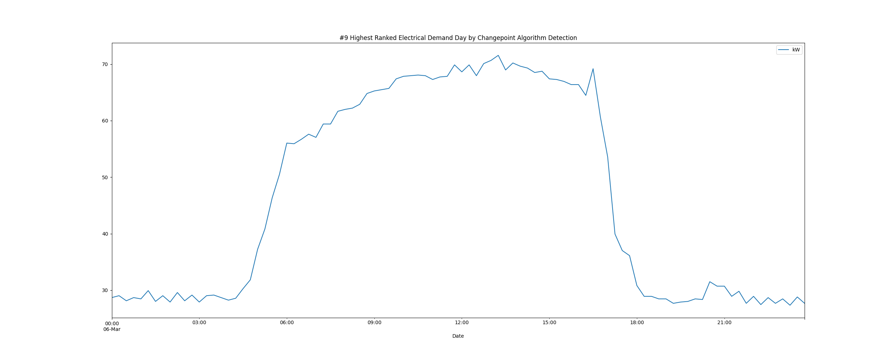

# Daily High and Low Load kW Values

highLowLoadsPlot.png

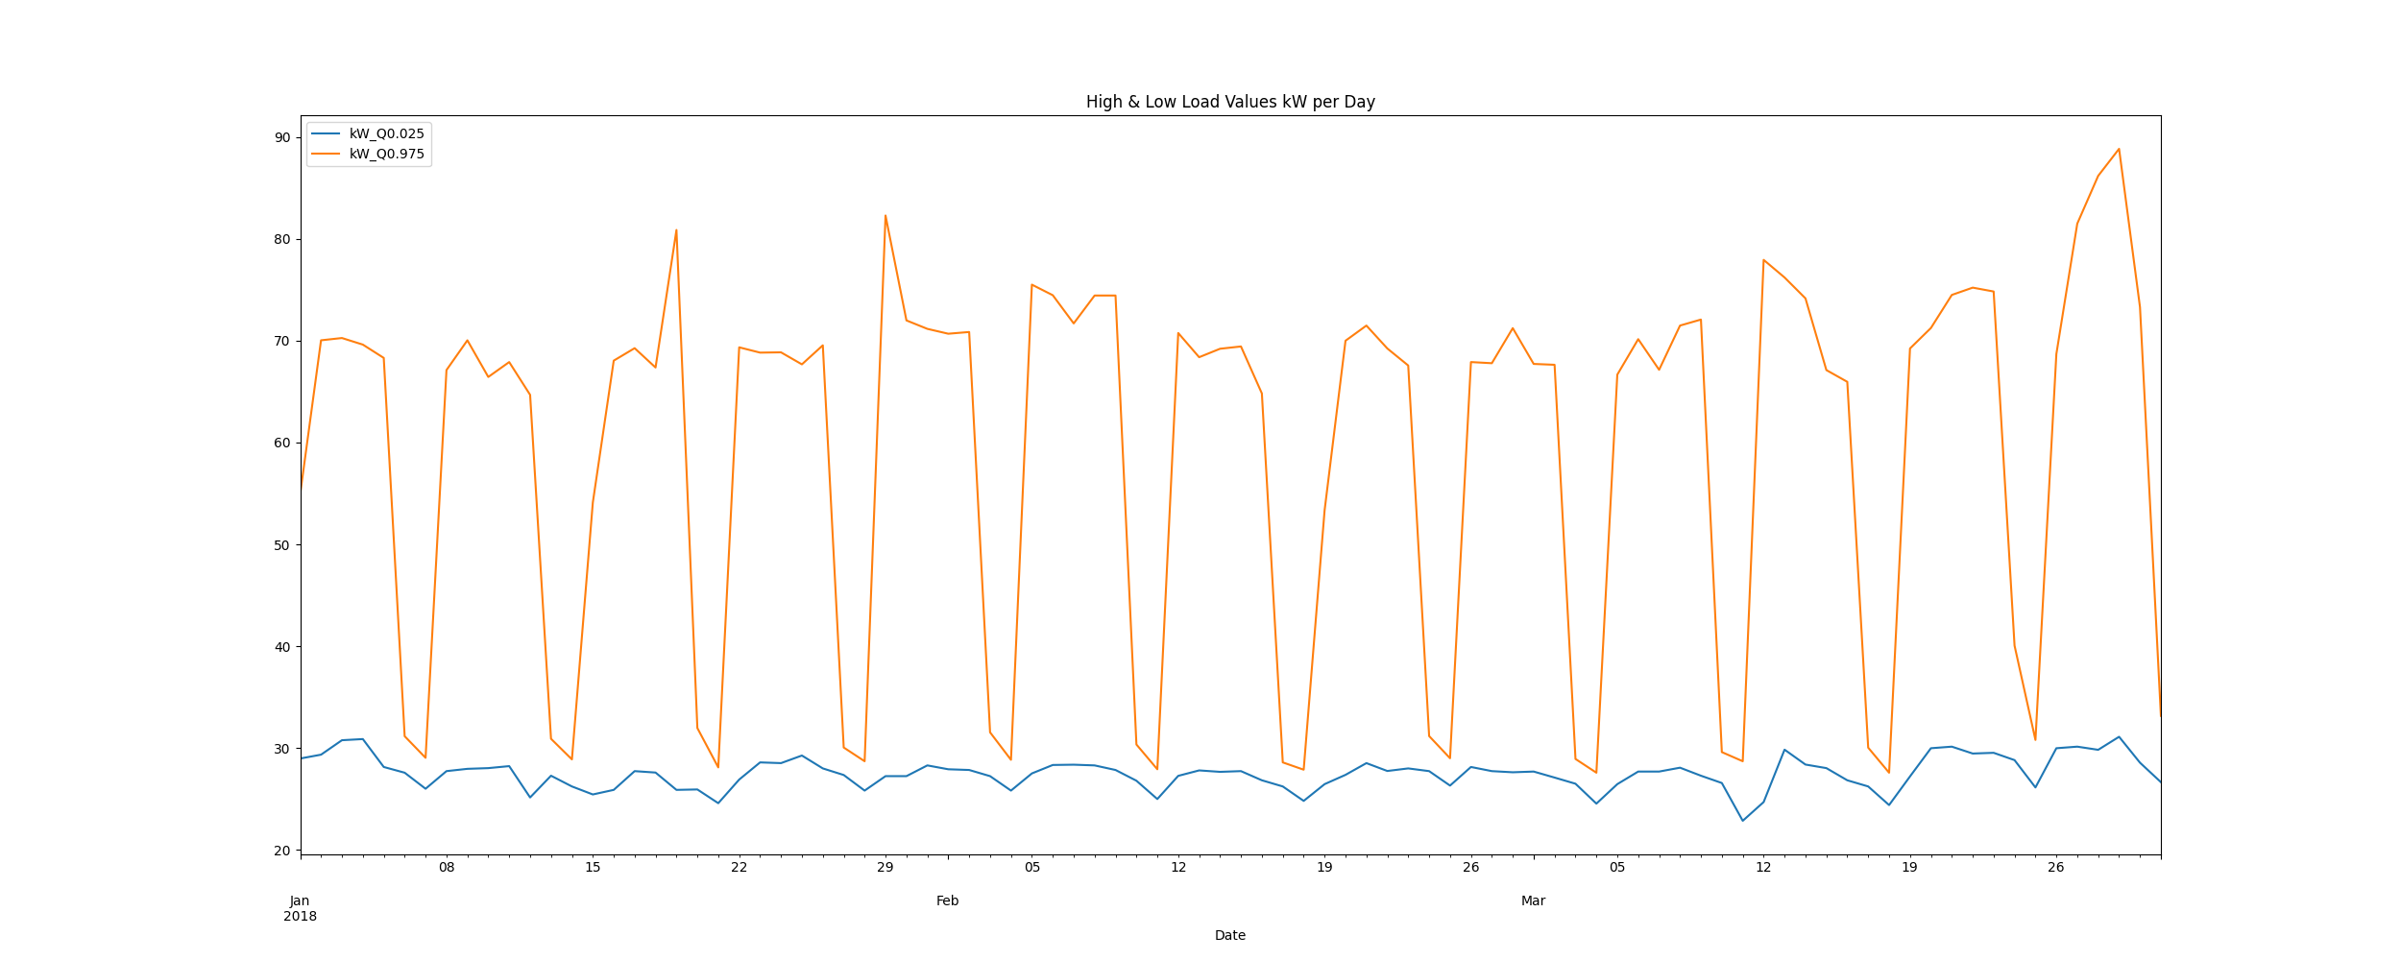

# Max Demand and Hour of Day Plot

Max_Demand_and_Max_Hour_of_Day.png

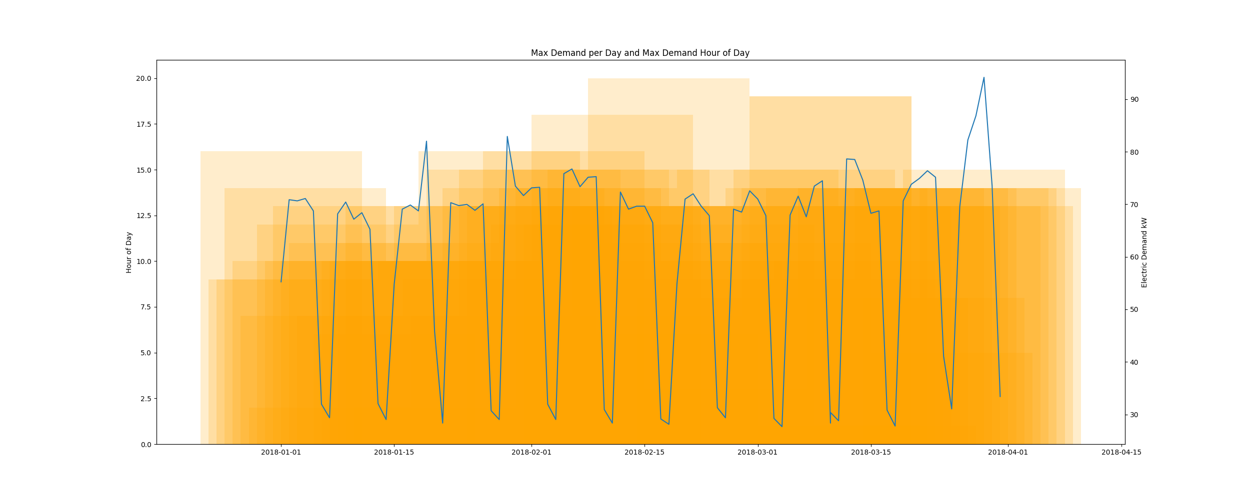

* Resampling the interval dataset to calculate units of energy KWh/day, the first day is 2018-01-01 and the last day is 2018-03-31
* Total days in dataset 89 days
* Total Sum of calculated electrical energy 91390.31619999999 kWh

# kWh Rolling 7 Day Avg

kWhRollingAvg.png

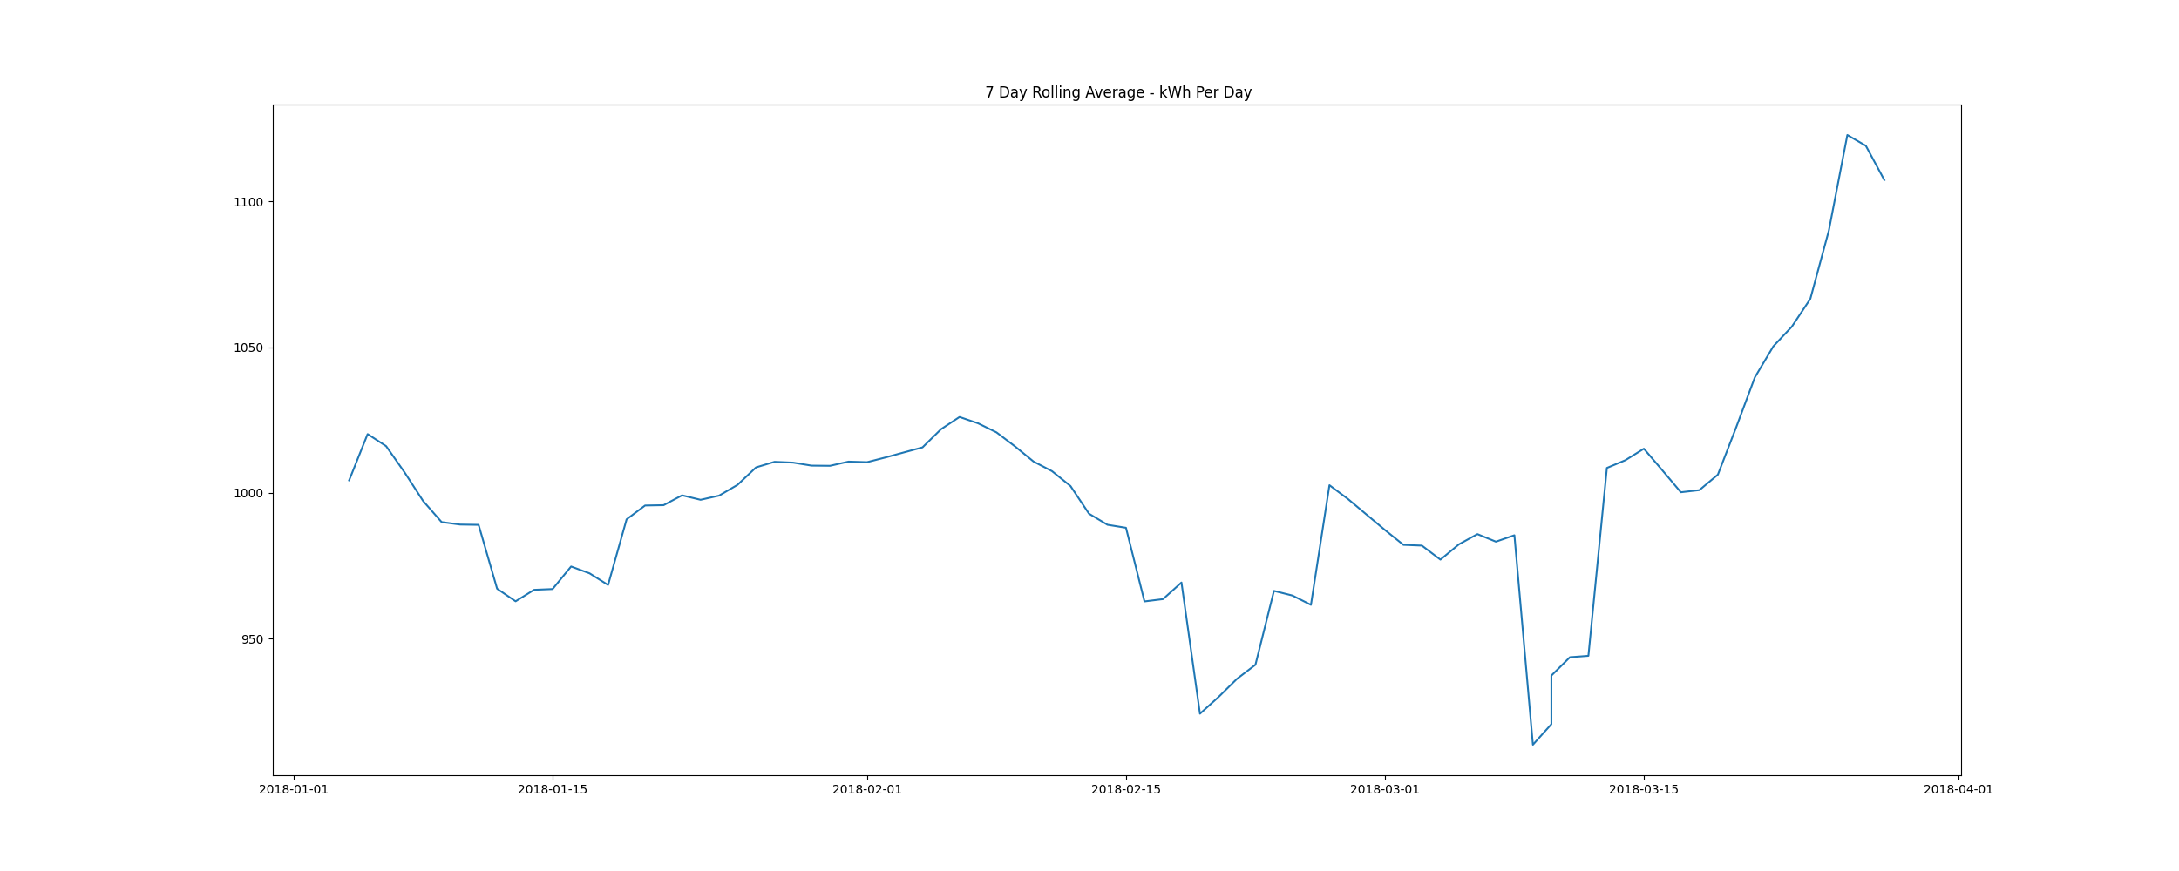

# Demand Plots By Month

Demands_for_Winter_Month_February.png

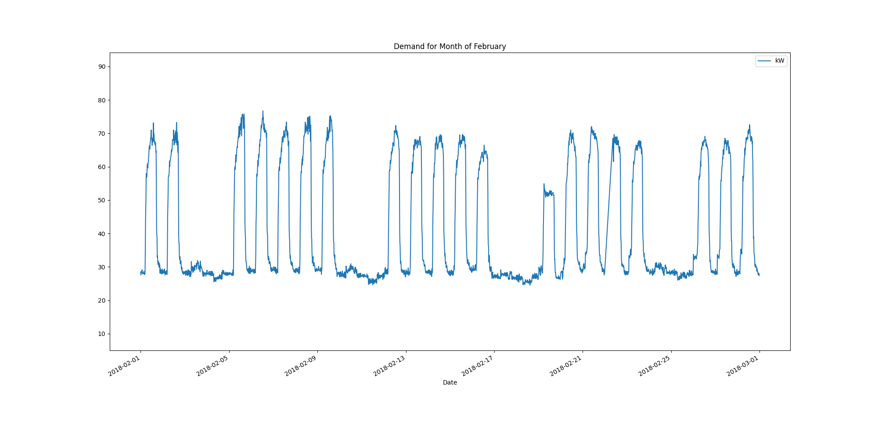

Demands_for_Winter_Month_January.png

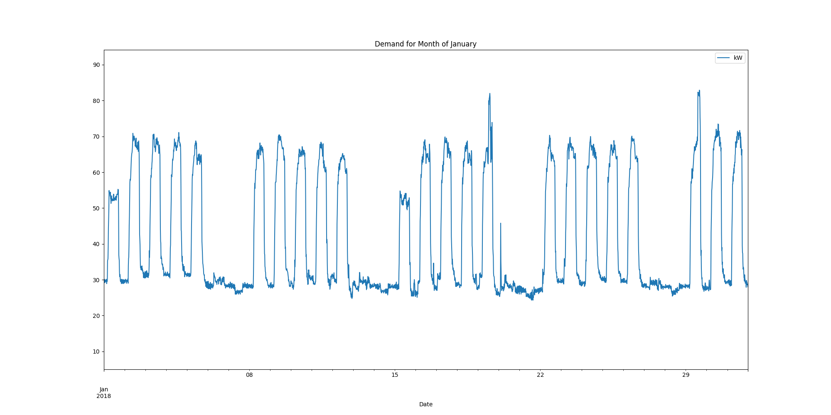

Demands_for_Winter_Month_March.png

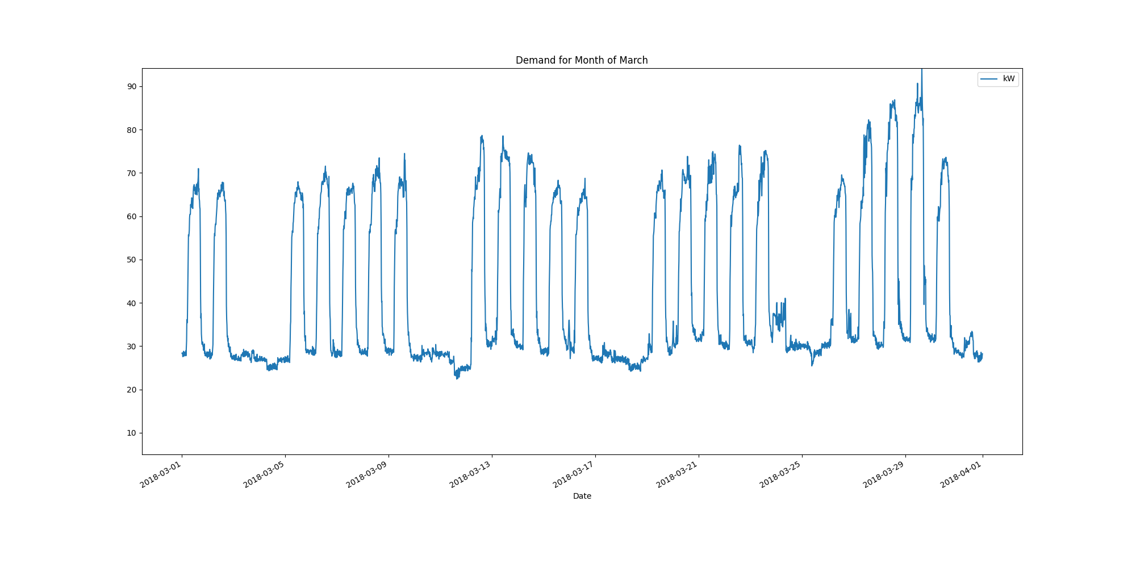

Data Analysis Report Summer

Summer Months Electrical Load Profiles

datasetPlot.png

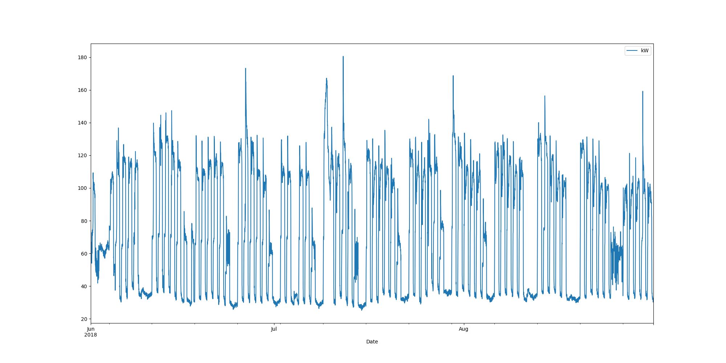

# Max Demand Found In Dataset

kW 180.562  
Name: 2018-07-12 06:30:00, dtype: float64

# Dataset Summary Statistics

kW  
count 8832.000000  
mean 72.570671  
std 36.526294  
min 25.200000  
25% 34.763000  
50% 66.938000  
75% 108.225000  
max 180.562000

# Highest Ranked Change Point Algorithm Detection

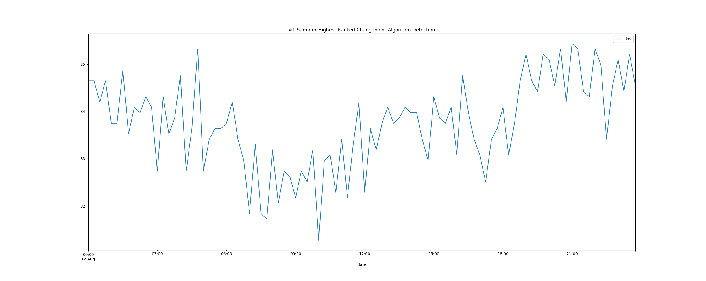

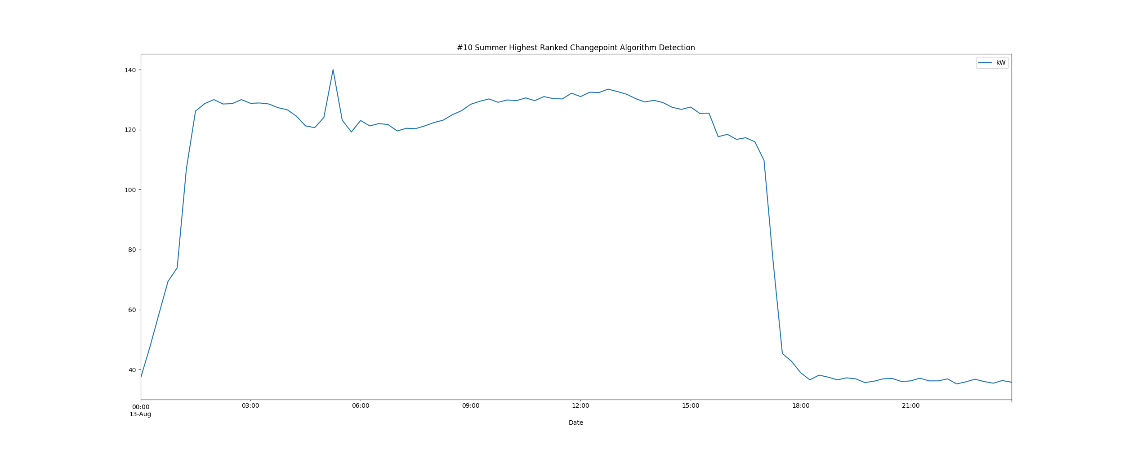

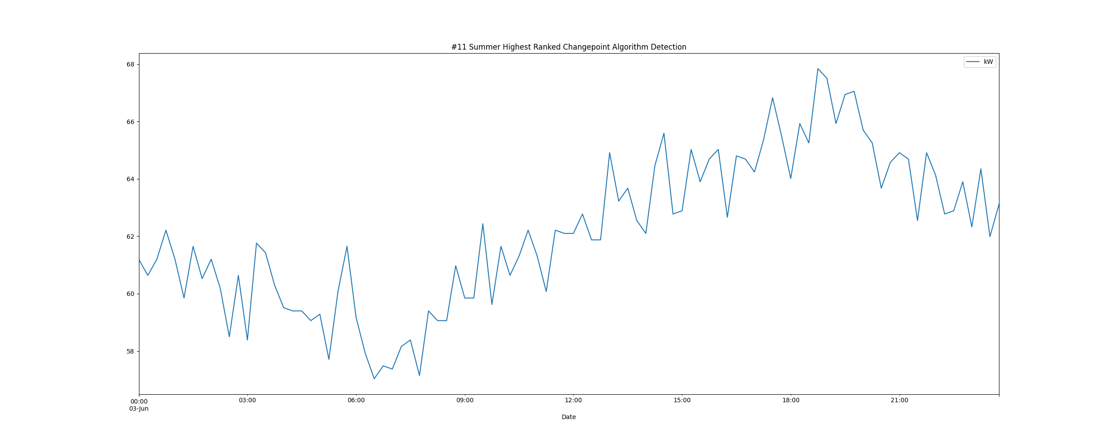

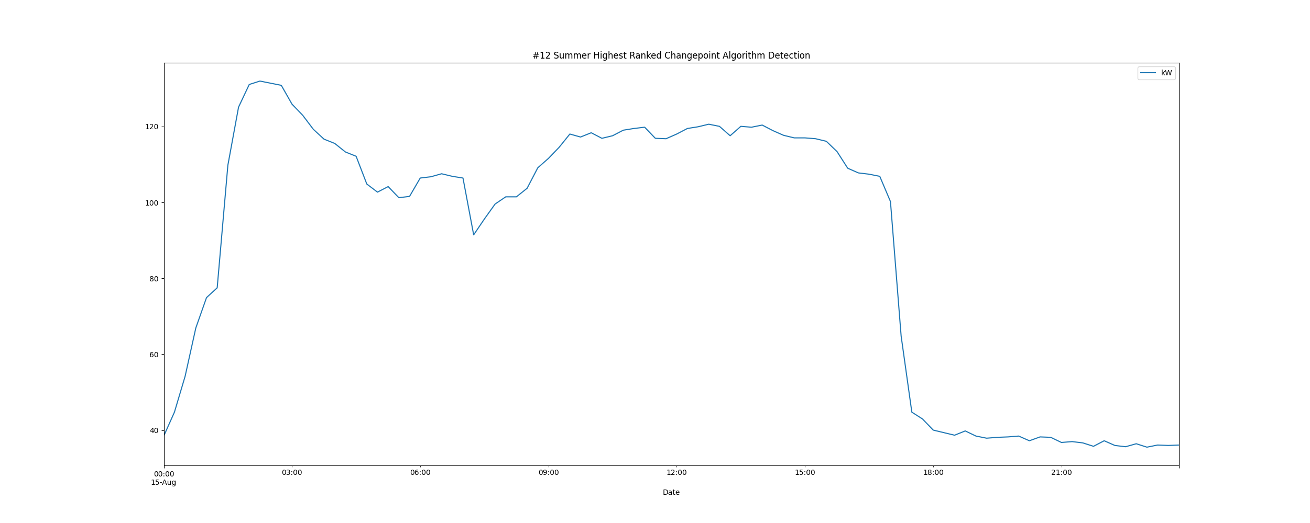

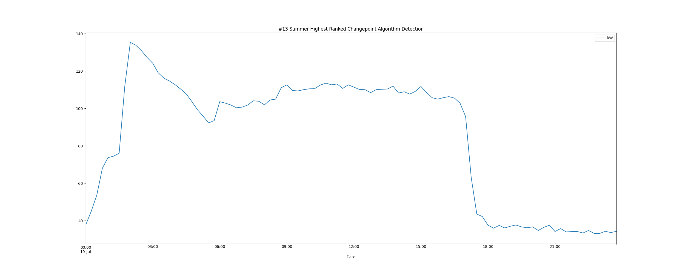

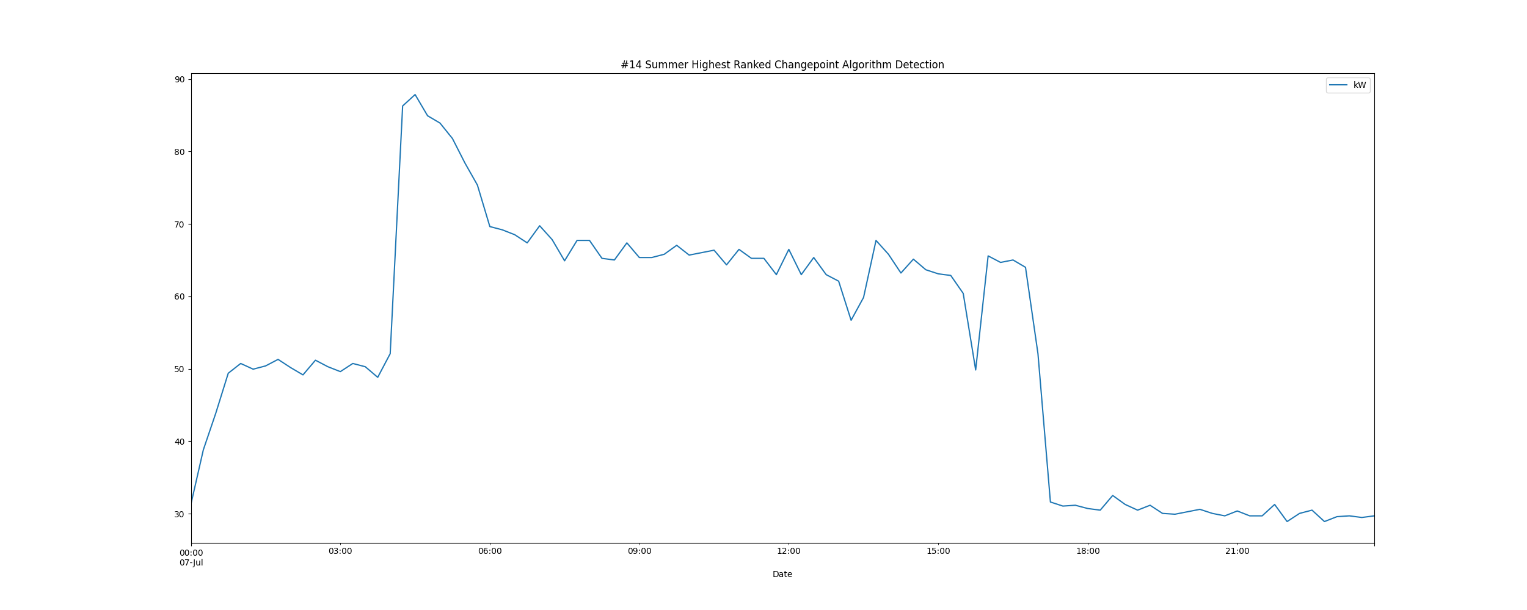

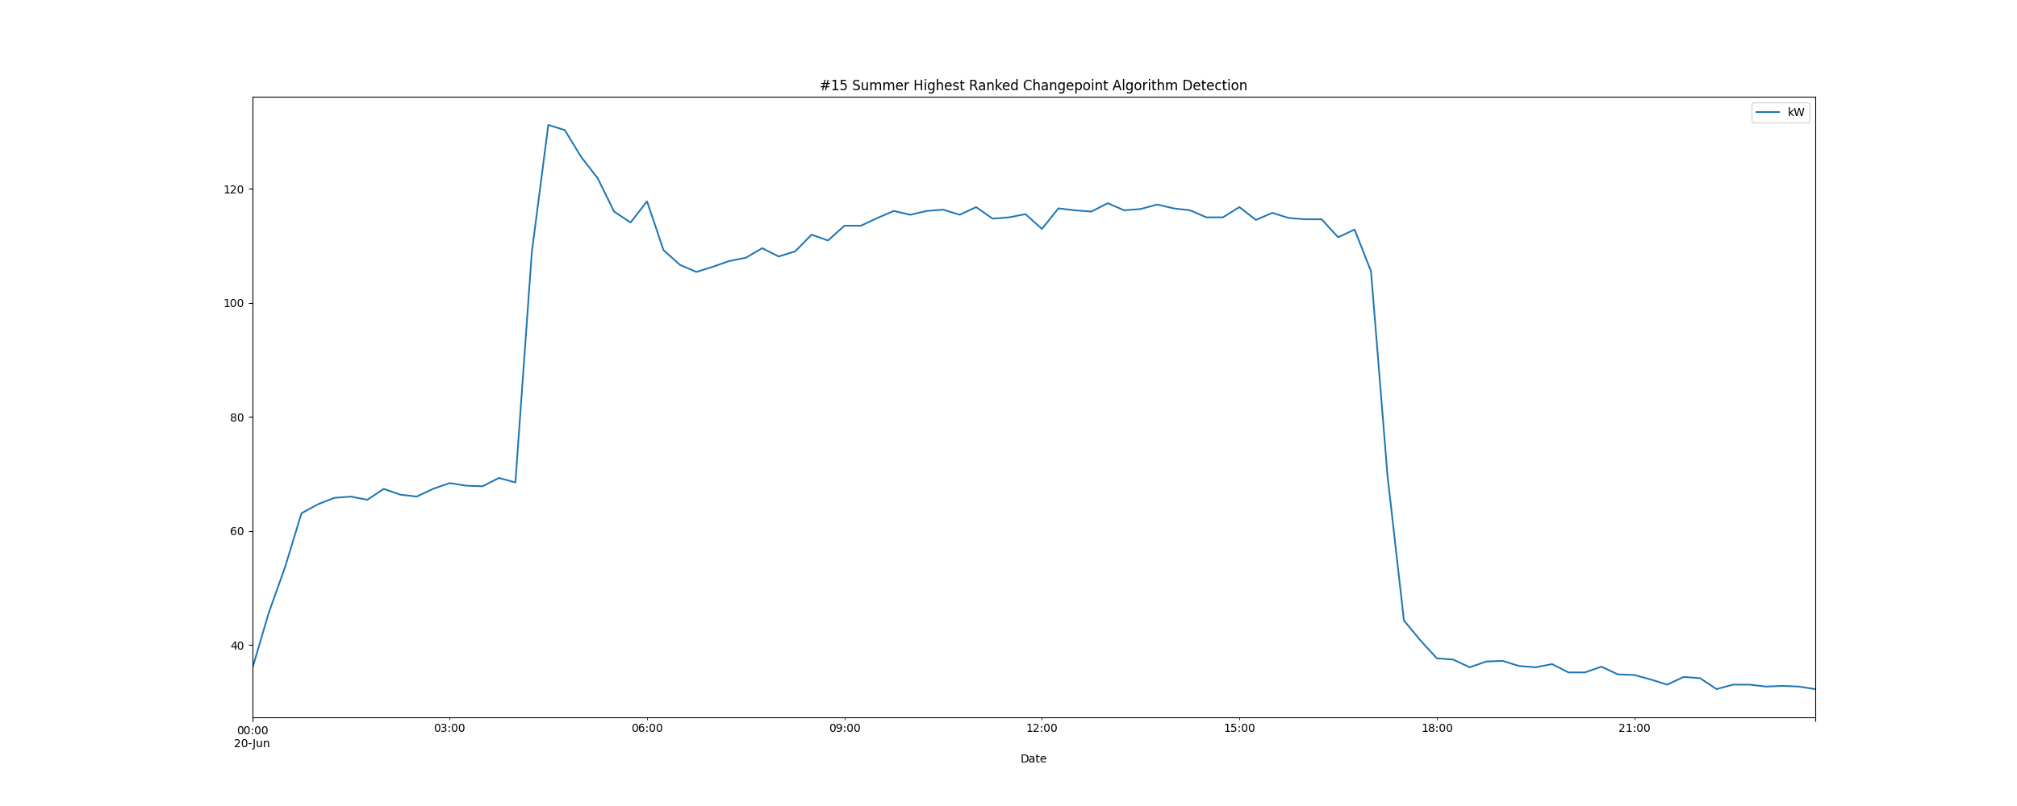

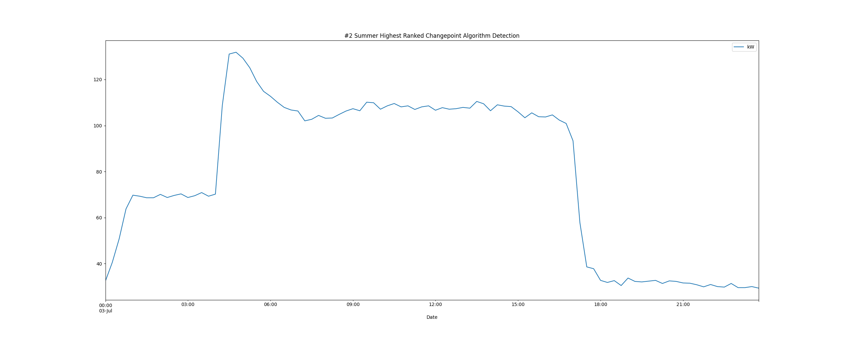

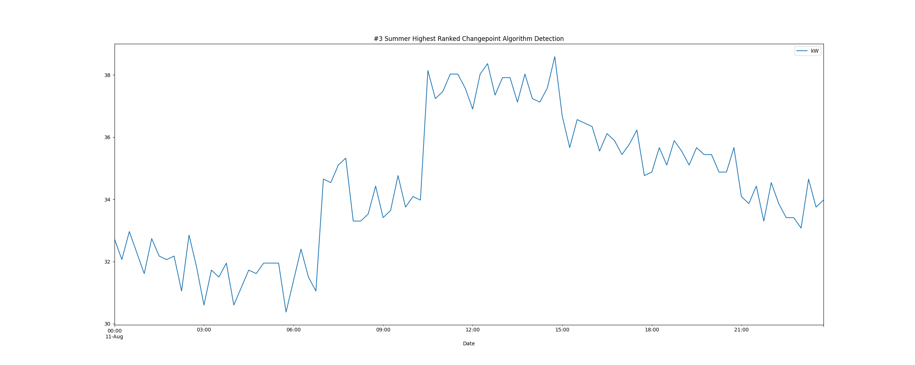

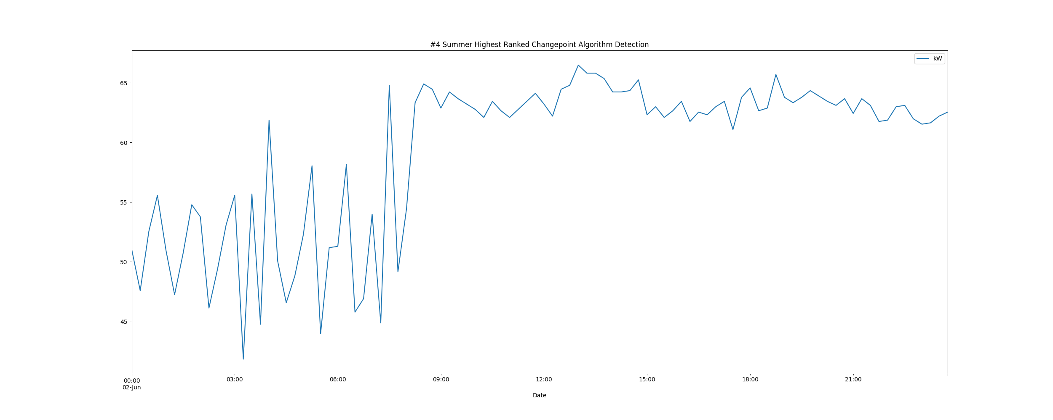

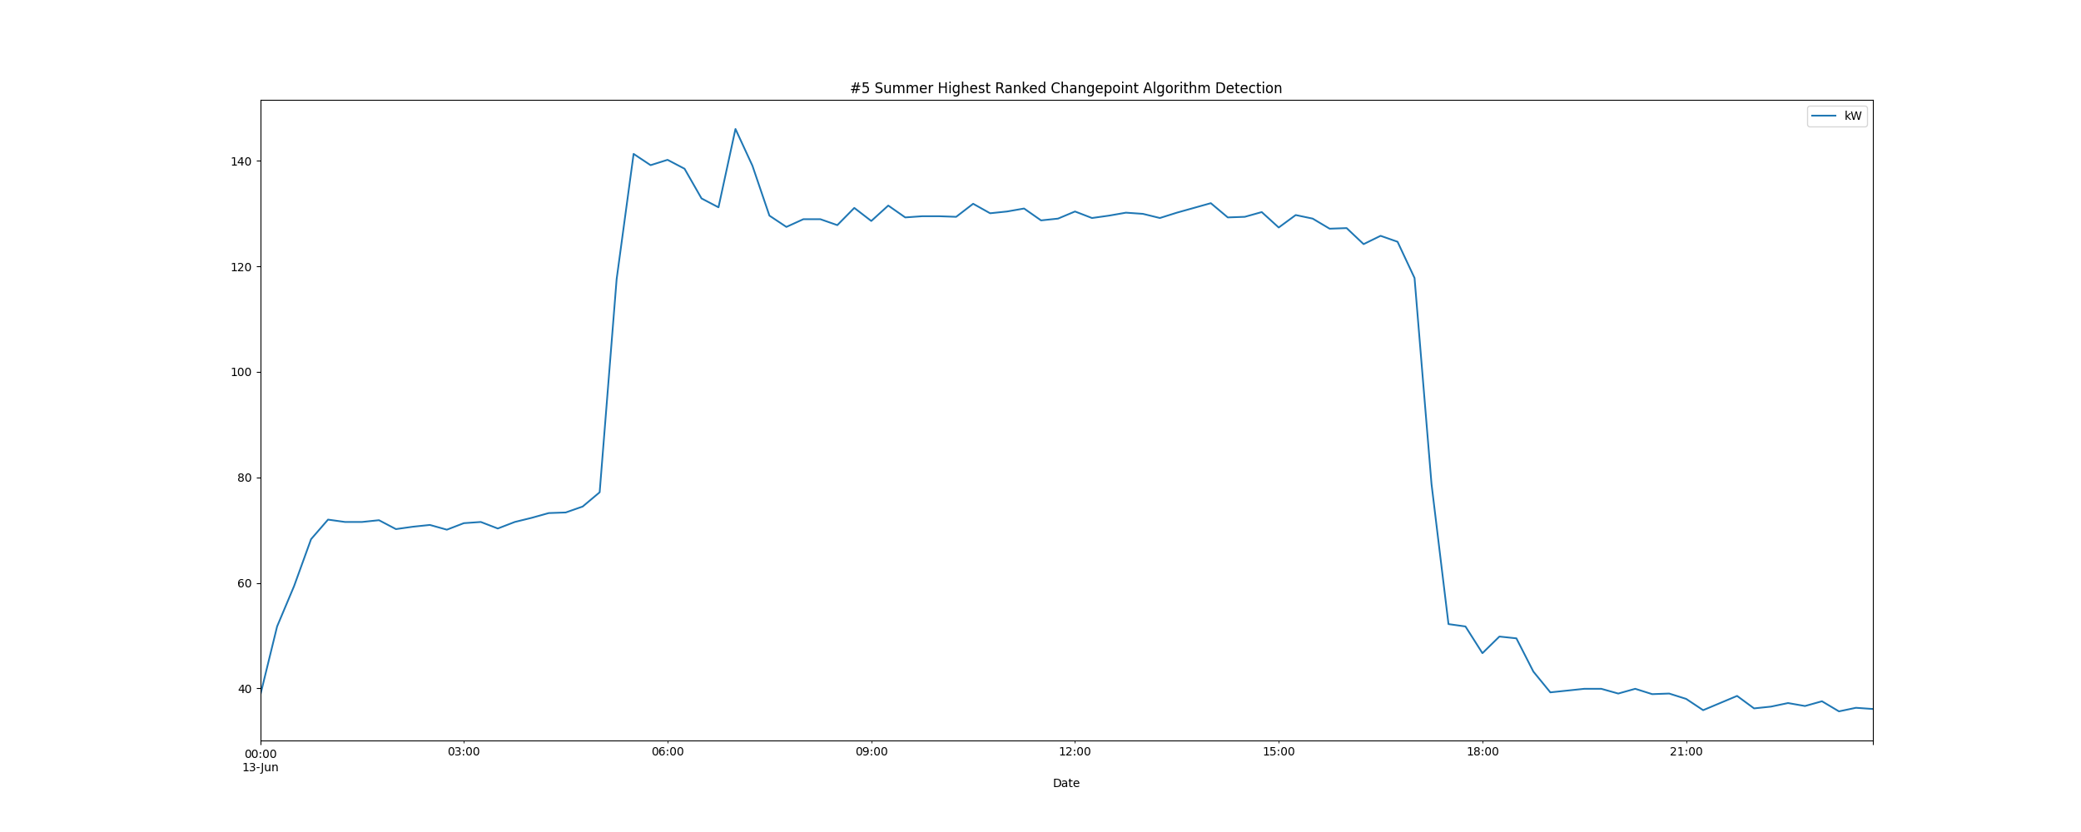

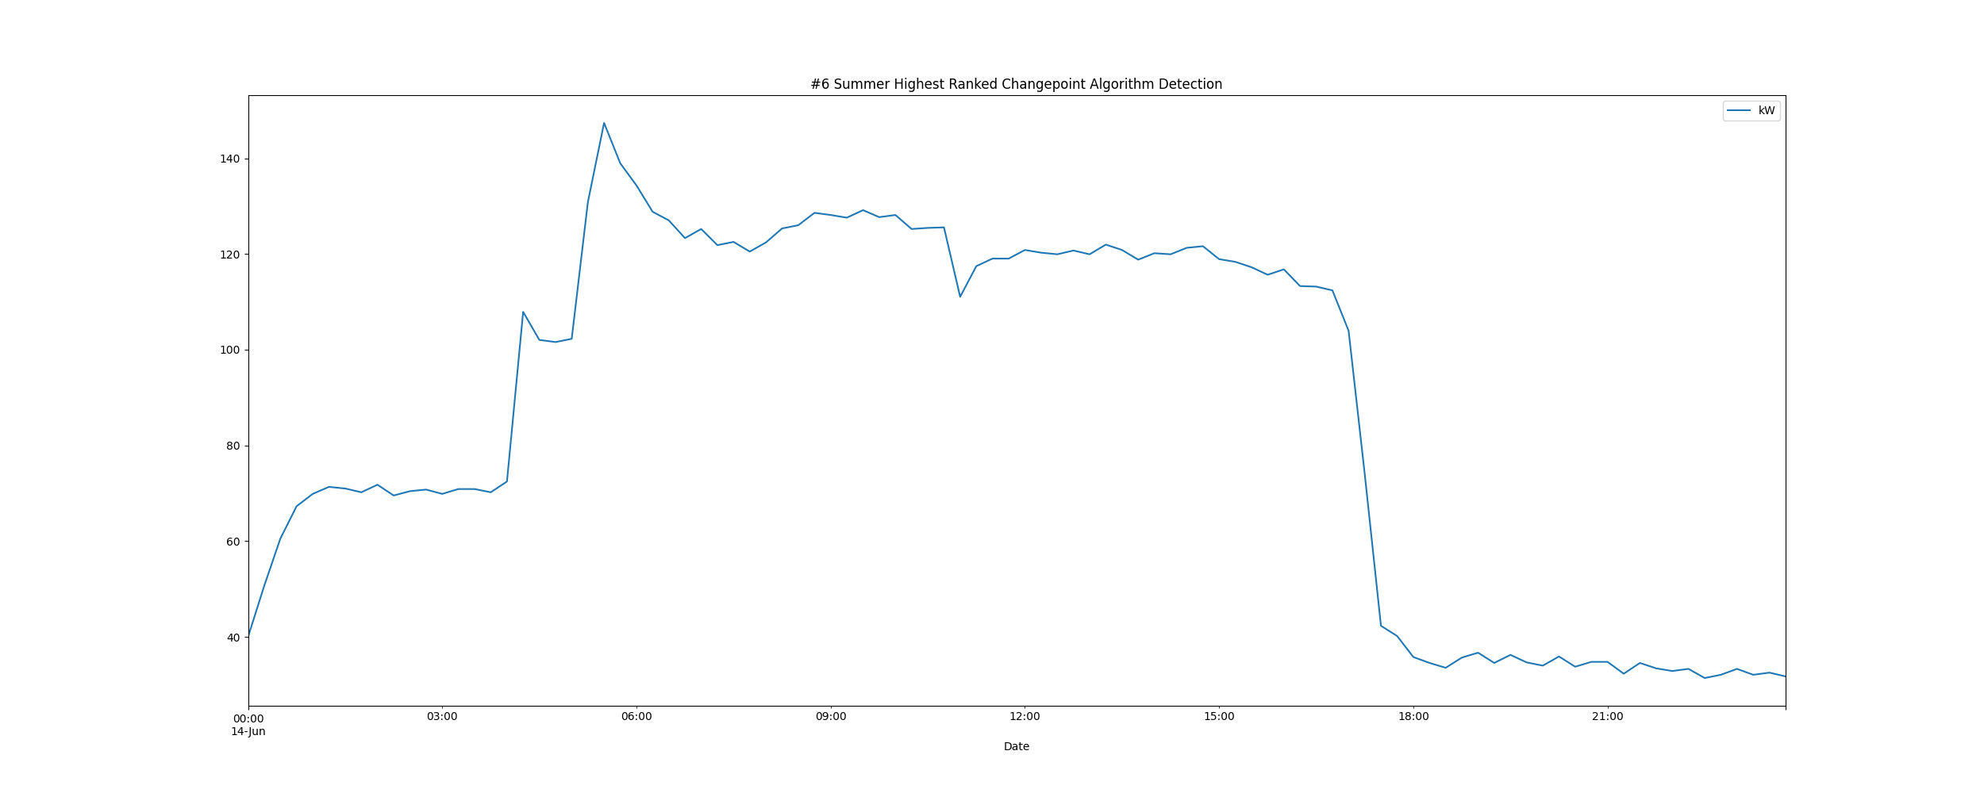

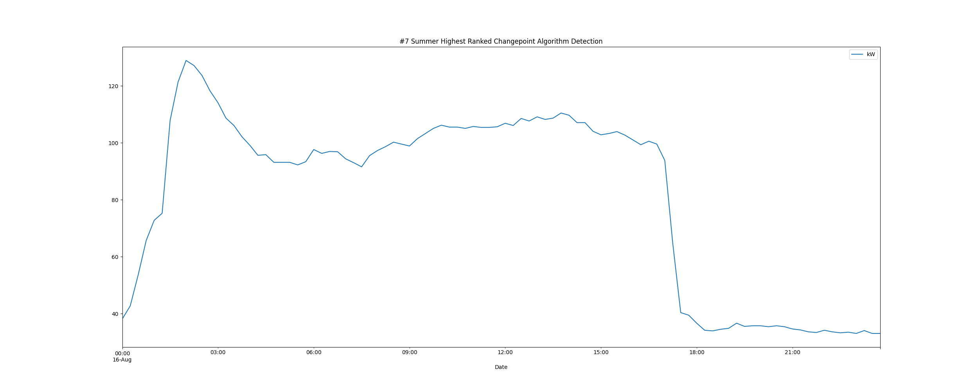

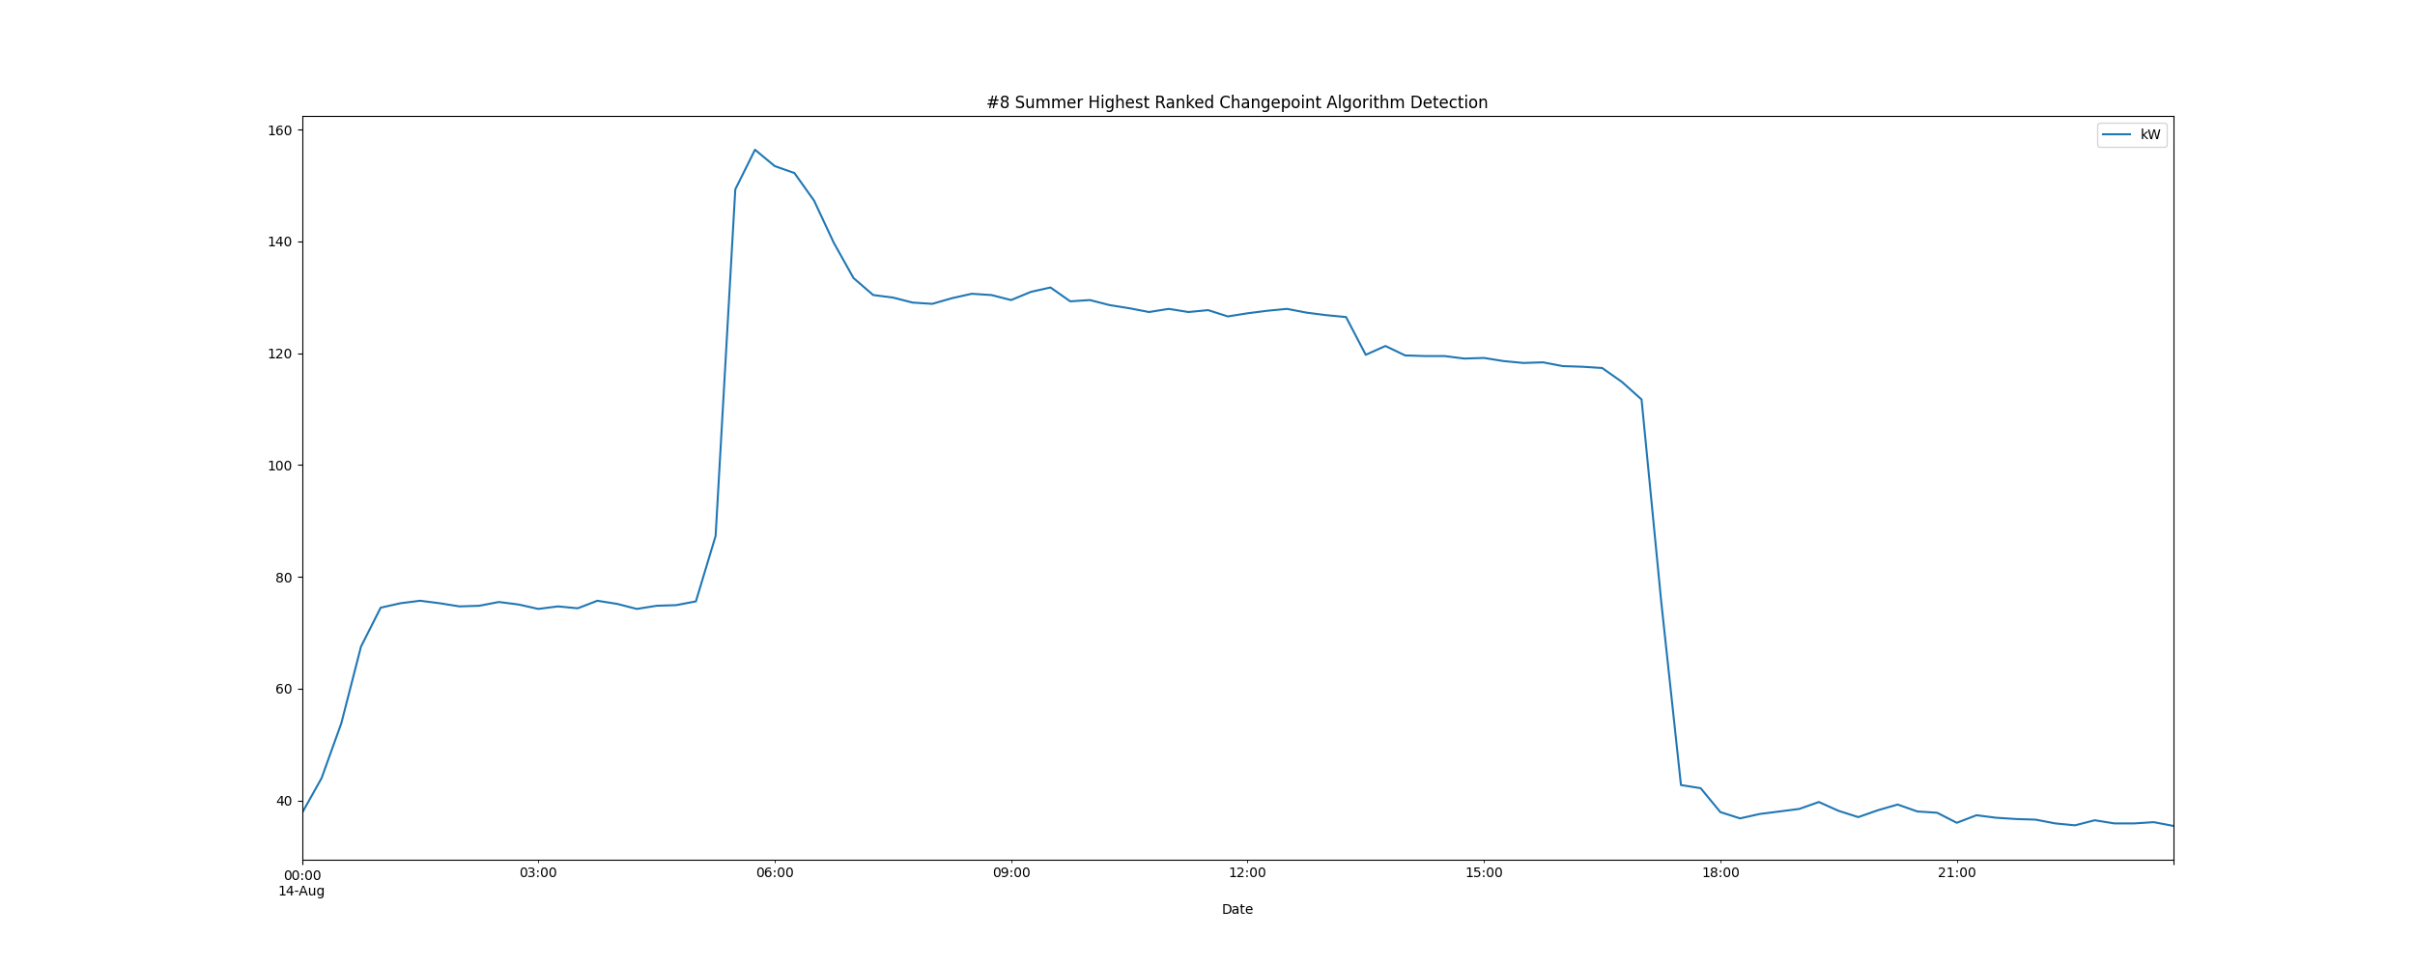

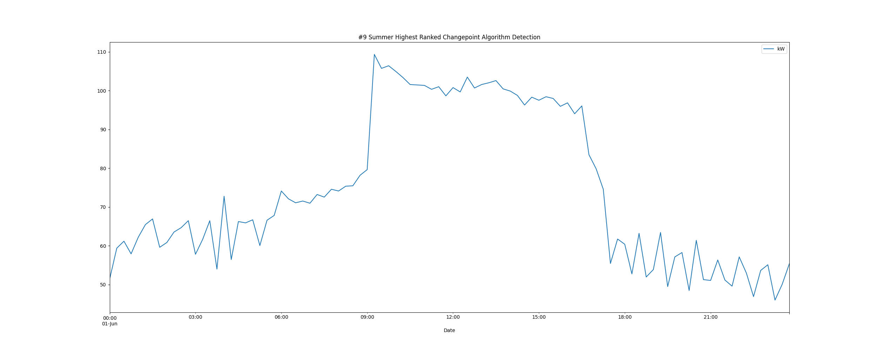

# Daily High and Low Load kW Values

highLowLoadsPlot.png

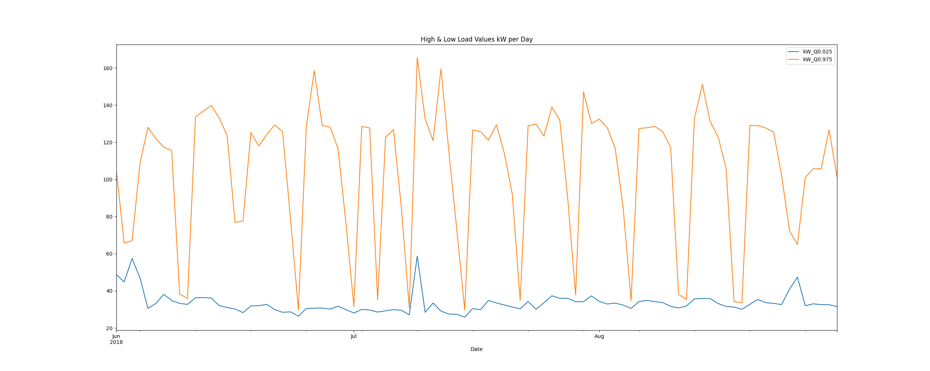

# Max Demand and Hour of Day Plot

Max_Demand_and_Max_Hour_of_Day.png

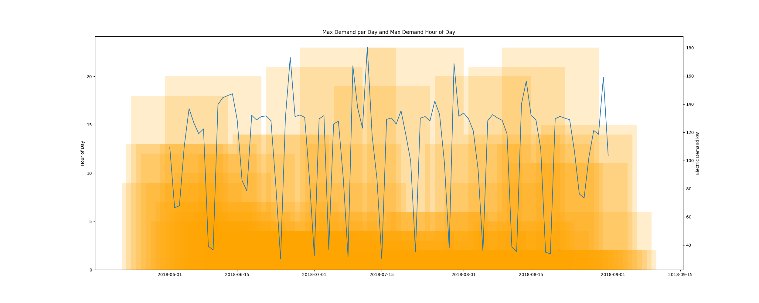

* Resampling the interval dataset to calculate units of energy KWh/day, the first day is 2018-06-01 and the last day is 2018-08-31
* Total days in dataset 91 days
* Total Sum of calculated electrical energy 160236.04125 kWh

# kWh Rolling 7 Day Avg

kWhRollingAvg.png

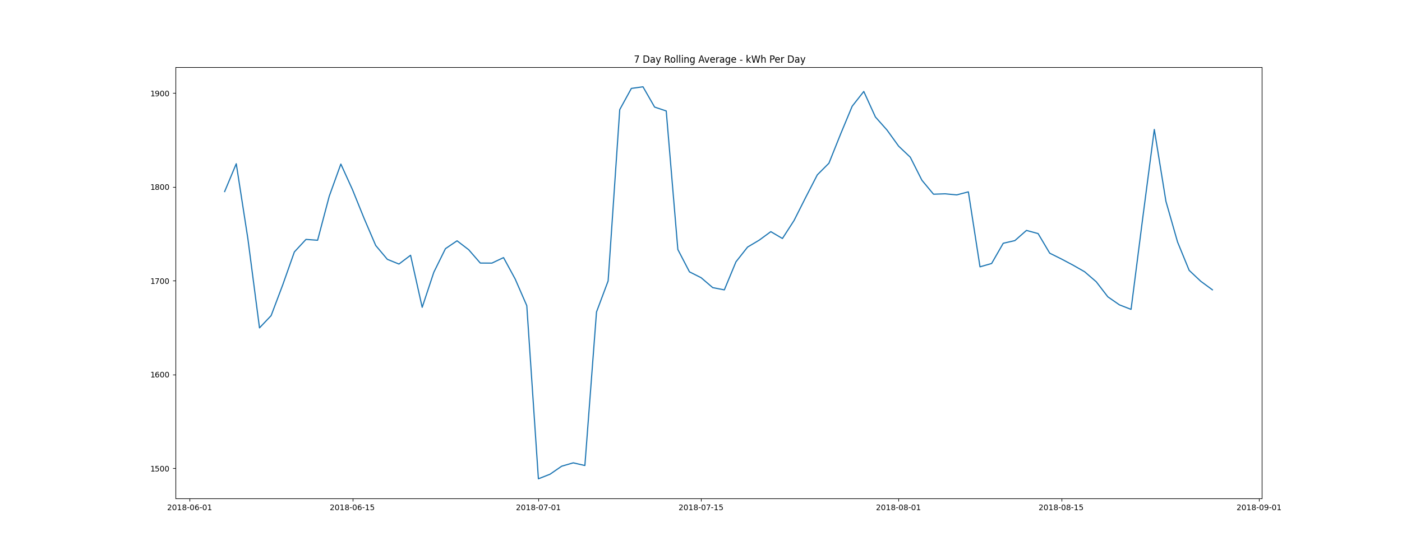

# Demand Plots By Month

Demands_for_Summer_Month_August.png

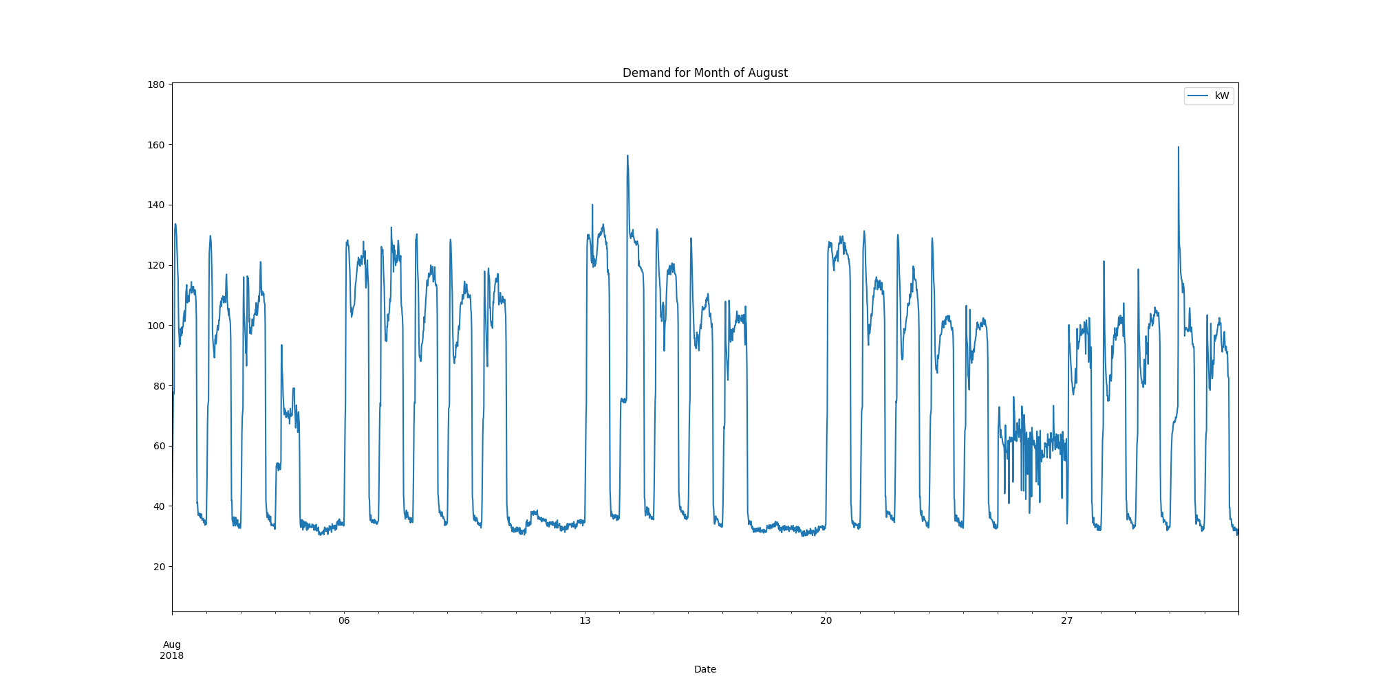

Demands_for_Summer_Month_July.png

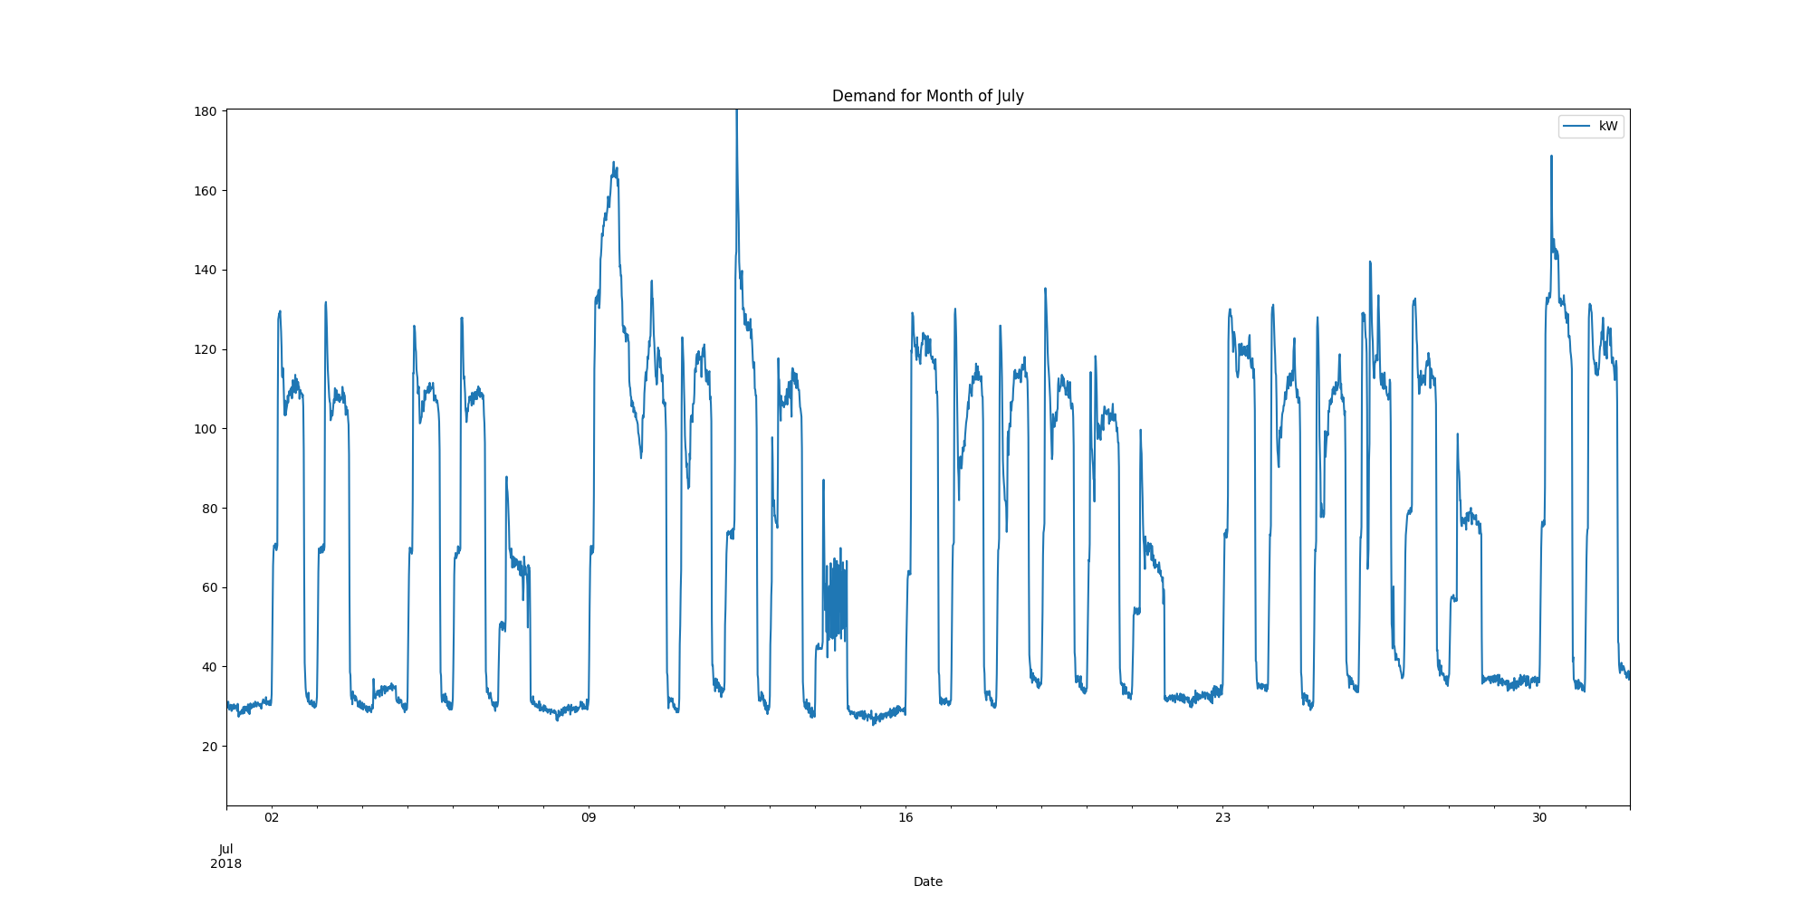

Demands_for_Summer_Month_June.png

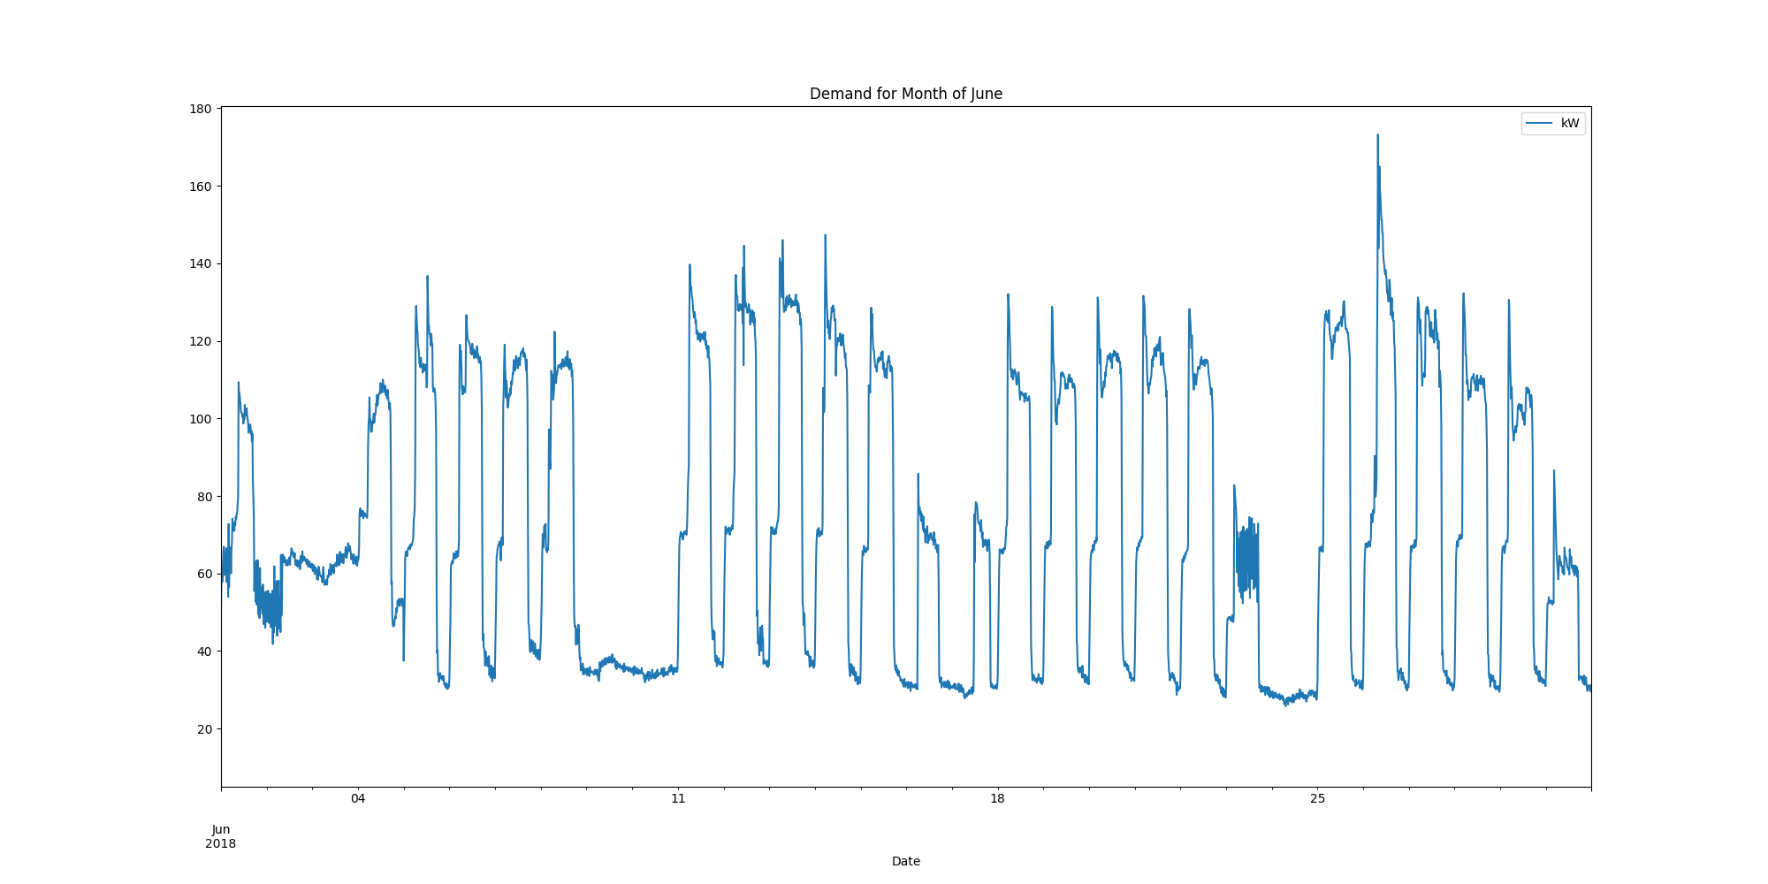

report compiled on:

08/04/2021 09:38:26